Product Bulletin for Supermicro CDE460 BIOS Upgrade to Version 2.1a

Contents

Problem Statement 1

Cisco Recommendation and Instruction 2

Requirements 2

Instruction on BIOS 2.1a Upgrade 3

Preparing a bootable USB stick to be used for the BIOS upgrade 3

Copy the CDE BIOS Update Files to the USB DOS Stick 3

Update System BIOS Using the USB Stick 4

Device Verification 5

For More Information 5

# 

# Problem Statement

Current CDE460 systems have been identified as potentially being vulnerable to the Intel Meltdown/Spectre vulnerabilities.

Meltdown and Spectre exploit critical vulnerabilities in modern processors. These hardware vulnerabilities allow programs to steal data which is currently processed on the computer. While programs are typically not permitted to read data from other programs, a malicious program can exploit Meltdown and Spectre to get hold of secrets stored in the memory of other running programs. This might include your passwords stored in a password manager or browser, your personal photos, emails, instant messages, and even business-critical documents.

# Cisco Recommendation and Instruction

* Upgrade BIOS to version 2.1a for seamless operation if you are using CDE460 devices.
* SDT version should be 2.113. The location to download, if not running already is <https://software.cisco.com/download/home/281150125/type/281934063/release/1.0.0>
  + SDT 2.113 patch for VDS-TV 4.x SW Application
  + SDT 2.113 patch for VDS-TV 3.x SW Application

# Requirements

* PC running Windows operating system
* USB stick (512MB or larger)
* Keyboard and monitor or direct I/O access, such as KVM

# Instruction on BIOS 2.1a Upgrade

### Preparing a bootable USB stick to be used for the BIOS upgrade

You should create a free-DOS USB boot stick by performing the following

1. Insert a blank USB memory stick into your Windows based PC.
2. Download and save the “rufus” USB boot device creator from <http://rufus.akeo.ie>
3. Start “**rufus**” by opening the “rufus_vx.x.x.exe” file.
4. Insert a USB stick to be formatted with FreeDOS.  
   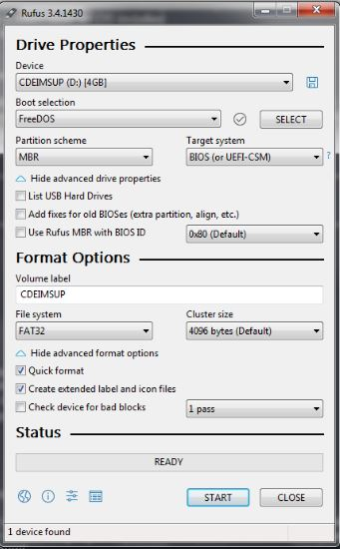  
   Figure1: Screenshot of Rufus utility
5. Choose **FreeDOS** option from the **Boot selection** drop-down list.
6. Enter **CDEIMSUP** in the **Volume label** field.
7. Choose **FAT32** option from the **File system** drop-down list.
8. Check the **Quick Format** checkbox.
9. Select Create a bootable disk using: “FreeDOS”
10. Click **Start** for the boot stick format to proceed.

## Copy the CDE BIOS Update Files to the USB DOS Stick

The CDE BIOS update files are available in the CDEIMSUP-CDE460.zip downloaded from the CCO.

1. Unzip CDEIMSUP-CDE460.zip to a temporary folder.
2. Copy the contents of the “CDEIMSUP-CDE460” directory to the root of the USB DOS stick.
3. Remove the USB DOS stick, and insert into any of the available USB ports on the rear end of the CDE system to be updated.
4. Connect a monitor and keyboard or KVM to the system to be updated.

### Update System BIOS Using the USB Stick

1. Boot to the USB DOS stick
2. All CDE systems are pre-configured at the factory to first boot to external USB devices, followed by the internal compact flash. If the system does not automatically boot to the USB DOS stick, verify the boot device priority in the BIOS or press **<F11>** or **<DELETE>** key during the system POST process.
3. After CDE system boots into a DOS prompt, initiate the IPMI BIOS upgrade by executing the CDEIMSUP.bat DOS batch file. For example, C:\> CDEIMSUP.bat

The following information is displayed:  
CDE250, CDE460, CDE465 BIOS Update for the Intel Meltdown/Spectre fixes

1. Select the option that matches the platform to be updated
   1. Update CDE2500 BIOS Version to 2.1a
   2. Update CDE460 BIOS Version to 2.1a
   3. Update CDE465 BIOS Version to 3.1

A message is displayed corresponding to the platform that is being updated. For example, “Update CDE460 BIOS Version to 2.1a”.

The entire BIOS upgrade will approximately take 10 minutes to complete. You should wait for a positive acknowledge from the utility prior to CDE system reboot. For example, “BIOS update to 2.1a has completed”  
 **Warning**Please DO NOT power-cycle and/or interrupt the BIOS upgrade process. Doing so may result in the system being placed into a non-recoverable state.

1. Enter **A** and press **Enter** for the upgrade to proceed when the following warning message is displayed.



1. After the BIOS upgrade is completed, ensure to first remove the USB DOS stick and then power-cycle the system.

### Device Verification

Once the device is booted up and application is loaded, you should login and execute the below commands to verify the device status.

* **head -1 /arroyo/image/tags**Displays the current running VDS-IS application software version.
* **dmidecode | grep Version**For example, Version: CDE460_2.1
* **sdt -v**For example, SuperDoctor II - Linux version 2.113(170412)

### For More Information

Please contact Cisco TAC team.