Date: July 6, 2015
Name of Product: Cisco Nexus 1K, 2K, 3K, 5K, and 7K Series Switches
Contact for more Information: Cisco Accessibility Corporate Compliance, accessibility@cisco.com

Summary Table - Voluntary Product Accessibility Template
Criteria | Supporting Features | Remarks and Explanations
Section 1194.21 Software Applications and Operating Systems | Included | All these switches use NX-OS Software, an operating system designed specifically for the data center. The product family leverages a command line interface (CLI) built into the Cisco NX-OS. The CLI is inherently 508 conformant because it is text based and relies on keyboard for navigation. All function of the router can be configured and monitored through the CLI.
Section 1194.22 Web-based internet information and applications | Not Applicable
Section 1194.23 Telecommunications Products | Not Applicable
Section 1194.24 Video and Multi-media Products | Not Applicable
Section 1194.25 Self-Contained, Closed Products | Included | The management tools (Graphical User Interfaces (GUI)) that are utilized to configure, operate, and manage the switches had been evaluated separately and have their own VPATs
Section 1194.26 Desktop and Portable Computers | Not Applicable
Section 1194.31 Functional Performance Criteria | Included
Section 1194.41 Information, Documentation and Support - Detail | Included

The following hardware appliances are considered exempt from Section 508 because of the 1194.3(f) Back Office Exemption Clause. Products located in spaces frequented only by service personnel for maintenance, repair, or occasional monitoring of equipment are not required to be compliant with section 508. The follow physical hardware product is considered back office equipment.

Cisco Nexus 1K, 2K, 3K, 5K, and 7K Series Switches
However, the software used to administer these hardware products is not exempt from Section 508. The remote configuration and management is done through Cisco NX-OS.

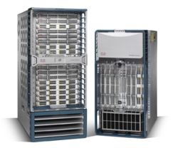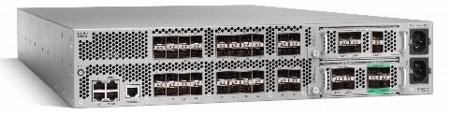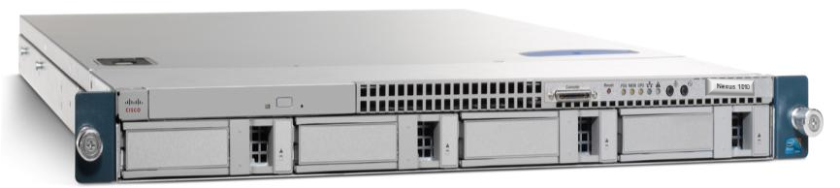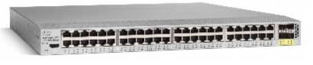
Figure 1 – Cisco Nexus 1K, 2K, 5K, and 7K Series Switches

URL for : http://www.cisco.com/en/US/products/ps9441/Products_Sub_Category_Home.html

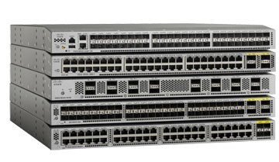
Figure 2 – Cisco Nexus 3K Series Switches

URL for: http://www.cisco.com/c/en/us/products/switches/nexus-3000-series-switches/index.html

Cisco NX-OS provides a robust and rich feature set that fulfills the routing, switching, and storage networking requirements of present and future data centers. With an XML interface and a command-line interface (CLI) like that of Cisco IOS® Software, Cisco NX-OS provides state-of-the-art implementations of relevant networking standards as well as a variety of true data center-class Cisco innovations.

Cisco NX-OS interoperates with Cisco products running any variant of the Cisco IOS Software operating system. Cisco NX-OS also interoperates with any networking OS that conforms to the networking standards listed as supported.

Section 1194.21: Software Applications and Operating Systems – Detail

Cisco NX-OS CLI
508 Clause | Criteria | Supporting Features | Remarks and Explanations
1194.21(a) | When software is designed to run on a system that has a keyboard, product functions shall be executable from a keyboard where the function itself or the result of performing a function can be discerned textually. | Supports | CLI provides keyboard access.
1194.21(b) | Applications shall not disrupt or disable activated features of other products that are identified as accessibility features, where those features are developed and documented according to industry standards. Applications also shall not disrupt or disable activated features of any operating system that are identified as accessibility features where the application programming interface for those accessibility features has been documented by the manufacturer of the operating system and is available to the product developer. | Supports
1194.21(c) | A well-defined on-screen indication of the current focus shall be provided that moves among interactive interface elements as the input focus changes. The focus shall be programmatically exposed so that Assistive Technology can track focus and focus changes. | Supports | CLI provides initial/keyboard focus.
1194.21(d) | Sufficient information about a user interface element including the identity, operation and state of the element shall be available to Assistive Technology. When an image represents a program element, the information conveyed by the image must also be available in text. | Supports | CLI is text based.
1194.21(e) | When bitmap images are used to identify controls, status indicators, or other programmatic elements, the meaning assigned to those images shall be consistent throughout an application's performance. | Not Applicable | No images or graphical elements in the CLI
1194.21(f) | Textual information shall be provided through operating system functions for displaying text. The minimum information that shall be made available is text content, text input caret location, and text attributes. | Supports | CLI is text based.
1194.21(g) | Applications shall not override user selected contrast and color selections and other individual display attributes. | Supports | Dependent on application used to access CLI.
1194.21(h) | When animation is displayed, the information shall be displayable in at least one non-animated presentation mode at the option of the user. | Not Applicable | No animations in the CLI
1194.21(i) | Color coding shall not be used as the only means of conveying information, indicating an action, prompting a response, or distinguishing a visual element. | Supports | CLI is text based and color is not used.
1194.21(j) | When a product permits a user to adjust color and contrast settings, a variety of color selections capable of producing a range of contrast levels shall be provided. | Supports | Dependent on application used to access CLI.
1194.21(k) | Software shall not use flashing or blinking text, objects, or other elements having a flash or blink frequency greater than 2 Hz and lower than 55 Hz. | Not Applicable | No instances of blinking or flashing.
1194.21(l) | When electronic forms are used, the form shall allow people using Assistive Technology to access the information, field elements, and functionality required for completion and submission of the form, including all directions and cues. | Not Applicable | No instances of electronic forms.

Section 1194.25: Self-Contained, Closed Products – Detail
Cisco Nexus 1K, 2K, 3K, 5K, and 7K Series Switches
508 Clause | Criteria | Supporting Features | Remarks and Explanations
1194.25(a) | Self contained products shall be usable by people with disabilities without requiring an end-user to attach Assistive Technology to the product. Personal headsets for private listening are not Assistive Technology. | Support | User with computers can connect to the switch either via console port or through telnet session that is compatible with assistive technology.
1194.25(b) | When a timed response is required, the user shall be alerted and given sufficient time to indicate more time is required. | Not Applicable | No instances of required timed responses.
1194.25(c) | Where a product utilizes touch screens or contact-sensitive controls, an input method shall be provided that complies with §1194.23 (k) (1) through (4). | Not Applicable
1194.25(d) | When biometric forms of user identification or control are used, an alternative form of identification or activation, which does not require the user to possess particular biological characteristics, shall also be provided. | Not Applicable | No instances of biometric forms of user identification or control.
1194.25(e) | When products provide auditory output, the audio signal shall be provided at a standard signal level through an industry standard connector that will allow for private listening. The product must provide the ability to interrupt, pause, and restart the audio at anytime. | Not Applicable | No instances of audio or listening features.
1194.25(f) | When products deliver voice output in a public area, incremental volume control shall be provided with output amplification up to a level of at least 65 dB. Where the ambient noise level of the environment is above 45 dB, a volume gain of at least 20 dB above the ambient level shall be user selectable. A function shall be provided to automatically reset the volume to the default level after every use. | Not Applicable | No instances of audio or listening features.
1194.25(g) | Color coding shall not be used as the only means of conveying information, indicating an action, prompting a response, or distinguishing a visual element. | Supports | The product use green led lights with blinking/flashing indicators. See 1194.25(j) for more information on the blinking/flashing instances.
1194.25(h) | When a product permits a user to adjust color and contrast settings, a range of color selections capable of producing a variety of contrast levels shall be provided. | Not Applicable | No instances of color or contrast settings.
1194.25(i) | Products shall be designed to avoid causing the screen to flicker with a frequency greater than 2 Hz and lower than 55 Hz. | Supports | Led lights blink during different states, but the blinking occurs in less than 1% of the physical layout of the device.
1194.25(j1) | Products which are freestanding, non-portable, and intended to be used in one location and which have operable controls shall comply with the following: The position of any operable control shall be determined with respect to a vertical plane, which is 48 inches in length, centered on the operable control, and at the maximum protrusion of the product within the 48 inch length on products which are freestanding, non-portable, and intended to be used in one location and which have operable controls. | Supports | This device is intended to be rack mounted. The dependency on meeting this requirement is the location in which the switch is placed in the rack.
1194.25(j2) | Products which are freestanding, non-portable, and intended to be used in one location and which have operable controls shall comply with the following: Where any operable control is 10 inches or less behind the reference plane, the height shall be 54 inches maximum and 15 inches minimum above the floor. | Supports | This device is intended to be rack mounted. The dependency on meeting this requirement is the location in which the switch is placed in the rack.
1194.25(j3) | (Products which are freestanding, non-portable, and intended to be used in one location and which have operable controls shall comply with the following: Where any operable control is more than 10 inches and not more than 24 inches behind the reference plane, the height shall be 46 inches maximum and 15 inches minimum above the floor. | Supports | This device is intended to be rack mounted. The dependency on meeting this requirement is the location in which the switch is placed in the rack.
1194.25(j4) | (Products which are freestanding, non-portable, and intended to be used in one location and which have operable controls shall comply with the following: Operable controls shall not be more than 24 inches behind the reference plane. | Supports | This device is intended to be rack mounted. The dependency on meeting this requirement is the location in which the switch is placed in the rack.

Section 1194.31: Functional Performance Criteria - Detail
508 Clause | Criteria | Supporting Features | Remarks and Explanations
1194.31(a) | At least one mode of operation and information retrieval that does not require user vision shall be provided, or support for Assistive Technology used by people who are blind or visually impaired shall be provided. | Support with Exceptions | Cisco does not recommend a person without vision to connect this device to AC or DC power source as it might pose a safety risk.  For software administration, each device can be managed through Cisco NX-OS command line interface (telnet or serial connections).
1194.31(b) | At least one mode of operation and information retrieval that does not require visual acuity greater than 20/70 shall be provided in audio and enlarged print output working together or independently, or support for Assistive Technology used by people who are visually impaired shall be provided. | Support with Exceptions | Cisco does not recommend a person with low vision to connect this device to AC or DC power source as it might pose a safety risk.  For software administration, each device can be managed through Cisco NX-OS command line interface (telnet or serial connections).
1194.31(c) | At least one mode of operation and information retrieval that does not require user hearing shall be provided, or support for Assistive Technology used by people who are deaf or hard of hearing shall be provided. | Not Applicable | No audio features.
1194.31(d) | Where audio information is important for the use of a product, at least one mode of operation and information retrieval shall be provided in an enhanced auditory fashion, or support for assistive hearing devices shall be provided. | Not Applicable | Not audio features.
1194.31(e) | At least one mode of operation and information retrieval that does not require user speech shall be provided, or support for Assistive Technology used by people with disabilities shall be provided. | Not Applicable | Not audio features.
1194.31(f) | At least one mode of operation and information retrieval that does not require fine motor control or simultaneous actions and that is operable with limited reach and strength shall be provided. | Support with Exceptions | Individuals with fine motor control may find it difficult to insert cables such as RJ-11 and RJ-45 or insert blades into the switch or placing the device into a rack.  For software administration, each device can be managed through Cisco NX-OS command line interface (telnet or serial connections).

Section 1194.41: Information, Documentation and Support
508 Clause | Criteria | Supporting Features | Remarks and Explanations
1194.41(a) | Product support documentation provided to end-users shall be made available in alternate formats upon request, at no additional charge | Supports | Accessible documentation is available through Cisco Technical Assistance Center (TAC) upon request.
1194.41(b) | End-users shall have access to a description of the accessibility and compatibility features of products in alternate formats or alternate methods upon request, at no additional charge. | Supports | Accessible documentation is available through Cisco Technical Assistance Center (TAC) upon request.
1194.41(c) | Support services for products shall accommodate the communication needs of end-users with disabilities. | Supports | Cisco conforms through equal facilitation. Customers may reach Cisco Technical Assistance Center (TAC) via Phone, Email or Web Form. All cases open through email or web are opened as Priority 3 cases. All Priority 1 or Priority 2 case can only be opened via the telephone. TTY users must call the Text Relay Service (TRS) by dialing 711 and have the TRS agent contact Cisco TAC via voice.

