DO NOT RELEASE THIS COMMUNICATION TO DISTRIBUTORS OR 2-TIERS PRIOR TO March 31, 2008.
Writer | Trina Huynh
Approved by
Goal of Message | Message Highlighting Revamped SCC Landing Page
Theaters Impacted | Global
Target Audience | Distributors and Indirect Resellers
Communications Title | SCC Landing Page will be Updated with a NEW Look and Feel on April 13, 2008
Cisco continues to strive to provide you an enhanced user experience. One of the ways Cisco will be addressing your needs for a simplified and efficient process is to update your current SCC landing page (http://www.cisco.com/go/scc).

You will see that the updated and user-friendly SCC landing page will make it easy for you to access training, service support, and login access to SCC for Indirect Resellers and Distributors (SMS3). In addition, you will be able to view the latest announcements and theater specific news and to past messages.

Cisco is excited to provide you with this updated page and encourage you to visit the new and improved SCC landing page on April 13, 2008. To access the updated landing page, click here.

New! Updated SCC Landing Page
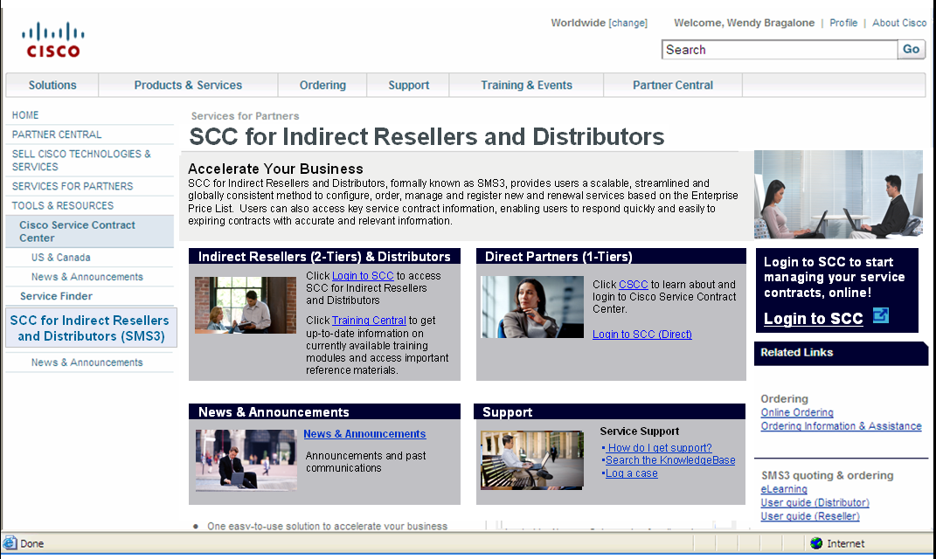
Login to SCC for Indirect Resellers and Distributors
Access training materials
Latest News
Past Announcements
Service Support links
Login to SCC for Indirect Resellers and Distributors

Actual link/URL | TBD
Contact Name or Alias | Trina Huynh  trinhuyn@cisco.com
** Please follow this layout as closely as possible to remain consistent with all of our communication efforts.

