Date: October 04, 2016
Name of Product: Cisco WebEx Product (web) Pages WBS31
Contact for more information: accessibility@cisco.com

The following testing was done on a Windows 7 with Freedom Scientific’s JAWs screen reader v17, Microsoft Accessibility Options (Filter keys and Display/Contrast settings), and standard Keyboard.

Summary Table - Voluntary Product Accessibility Template
Criteria | Supporting Features | Remarks and Explanations
Section 1194.21 Software Applications and Operating Systems | Not Applicable
Section 1194.22 Web-based internet information and applications | Included
W3C WCAG 2.0 Checkpoints | Included
Section 1194.23 Telecommunications Products | Not Applicable
Section 1194.24 Video and Multi-media Products | Not Applicable
Section 1194.25 Self-Contained, Closed Products | Not Applicable
Section 1194.26 Desktop and Portable Computers | Not Applicable
Section 1194.31 Functional Performance Criteria | Included
Section 1194.41 Information, Documentation and Support | Included

All contents are Copyright © 1992-2016 Cisco Systems, Inc. All rights reserved.

This information is true and correct to the best of our knowledge as of the Last Updated date printed below; is supplied for market research purposes only; and is subject to change without notice. The contents of this document do not constitute either legal advice, representation, warranty or guarantee regarding a person's ability to comply with applicable accessibility requirements. Such a determination is the sole responsibility of the purchaser.

For more information, please contact: accessibility@cisco.com Last Updated: October 04, 2016

Version of the Product

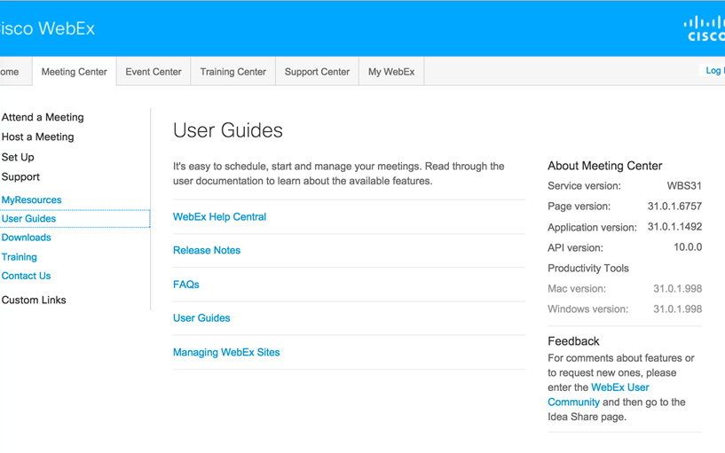

Section 1194.22: Web-based Internet information and applications – Detail
Clause | Criteria | Status | Remarks and Explanations
1194.22(a) | A text equivalent for every non-text element shall be provided (e.g., via "alt", "longdesc", or in element content). | Supports with Exceptions | Some non-text content do not have equivalent text description.
1194.22(b) | Equivalent alternatives for any multimedia presentation shall be synchronized with the presentation. | Not Applicable | Website does not have multimedia content.
1194.22(c) | Web pages shall be designed so that all information conveyed with color is also available without color, for example from context or markup. | Supports
1194.22(d) | Documents shall be organized so they are readable without requiring an associated style sheet. | Supports with Exceptions | Equivalent Facilitation is provided to support low vision users in high contrast. Some elements are not visible in high contrast schemes.
1194.22(e) | Redundant text links shall be provided for each active region of a server-side image map. | Not Applicable | Web site does not use server-side image map.
1194.22(f) | Client-side image maps shall be provided instead of server-side image maps except where the regions cannot be defined with an available geometric shape. | Not Applicable | Web site does not use client-side image map.
1194.22(g) | Row and column headers shall be identified for data tables. | Supports with Exceptions | Some data tables do not fully support screen reader software.
1194.22(h) | Markup shall be used to associate data cells and header cells for data tables that have two or more logical levels of row or column headers. | Not Applicable | Web site does not contain complex data tables.
1194.22(i) | Frames shall be titled with text that facilitates frame identification and navigation. | Supports
1194.22(j) | Pages shall be designed to avoid causing the screen to flicker with a frequency greater than 2 Hz and lower than 55 Hz. | Not Applicable | Web site does not have flashing content.
1194.22(k) | A text-only page, with equivalent information or functionality, shall be provided to make a web site comply with the provisions of this part, when compliance cannot be accomplished in any other way. The content of the text-only page shall be updated whenever the primary page changes. | Does Not Support | No text-only page provided.
1194.22(l) | When pages utilize scripting languages to display content, or to create interface elements, the information provided by the script shall be identified with functional text that can be read by assistive technology. | Supports with Exceptions | Some pages do not fully support screen reader software.
1194.22(m) | When a web page requires that an applet, plug-in or other application be present on the client system to interpret page content, the page must provide a link to a plug-in or applet that complies with §1194.21(a) through (l). | Not Applicable | Web site does not use applet or plug-in content
1194.22(n) | When electronic forms are designed to be completed on-line, the form shall allow people using assistive technology to access the information, field elements, and functionality required for completion and submission of the form, including all directions and cues. | Supports with Exceptions | Some forms elements do not fully support screen reader software.
1194.22(o) | A method shall be provided that permits users to skip repetitive navigation links. | Supports
1194.22(p) | When a timed response is required, the user shall be alerted and given sufficient time to indicate more time is required. | Not Applicable | Web Site does not have timed response pages.

W3C WCAG 2.0 Checkpoints – Detail
Checkpoint | Description | Status | Remarks and Explanations
1.1.1 (A) | Non text content | Supports with Exceptions | Some text alternative of non-text content are not announced by screen reader software.
1.2.1 (A) | Audio-only and Video-only (Prerecorded) | Not Applicable | No prerecorded audio-only/video-only content.
1.2.2 (A) | Captions (Prerecorded) | Not Applicable | No prerecorded audio/video.
1.2.3 (A) | Audio Description or Media Alternative (Prerecorded) | Not Applicable | No prerecorded audio/video.
1.2.4 (AA) | Captions (Live) | Not Applicable | No live audio/video content.
1.2.5 (AA) | Audio Description (Prerecorded) | Not Applicable | No prerecorded audio content.
1.3.1 (A) | Info and Relationships | Supports with Exceptions | Some form elements and data tables do not fully support screen reader.
1.3.2 (A) | Meaningful Sequence | Supports with Exceptions | Some pages do not fully support screen reader.
1.3.3 (A) | Sensory Characteristics | Not Applicable | No items that rely on sensory information.
1.4.1 (A) | Use of Color | Supports
1.4.2 (A) | Audio Control | Not Applicable | No audio that is played automatically.
1.4.3 (AA) | Contrast (Minimum) | Supports with Exceptions | Some elements are not visible in high contrast schemes.  Some text do not meet minimum contrast ratio.
1.4.4 (AA) | Resize Text | Supports
1.4.5 (AA) | Images of Text | Not Applicable | No images of text found.
2.1.1 (A) | Keyboard | Supports with Exceptions | Some elements are not accessible by keyboard.
2.1.2 (A) | No Keyboard Trap | Supports
2.2.1 (A) | Timing Adjustable | Not Applicable | No timed response pages found.
2.2.2 (A) | Pause, Stop, Hide | Not Applicable | No blinking or flashing contents.
2.3.1 (A) | Three Flashes or Below Threshold | Not Applicable | No flashing content.
2.4.1 (A) | Bypass Blocks | Supports with Exceptions | Website does not provide option to skip menu.
2.4.2 (A) | Page Titled | Supports with Exceptions | Some pages do not have page title.
2.4.3 (A) | Focus Order | Supports with Exceptions | Some pages do not have logical focus order.
2.4.4 (A) | Link Purpose (In Context) | Supports
2.4.5 (AA) | Multiple Ways | Supports with Exceptions | Some tabs have only one way to reach them.
2.4.6 (AA) | Headings and Labels | Supports with Exceptions | Some pages do not have hierarchical heading.
2.4.7 (AA) | Focus Visible | Supports with Exceptions | Some elements do not have visible focus.
3.1.1 (A) | Language of Page | Does Not Support | The default language information is not specified.
3.1.2 (AA) | Language of Parts | Not Applicable
3.2.1 (A) | On Focus | Supports
3.2.2 (A) | On Input | Supports
3.2.3 (AA) | Consistent Navigation | Supports
3.2.4 (AA) | Consistent Identification | Supports
3.3.1 (A) | Error Identification | Supports
3.3.2 (A) | Labels or Instructions | Supports with Exceptions | Screen reader does not announce that form field is required.
3.3.3 (AA) | Error Suggestion | Supports
3.3.4 (AA) | Error Prevention (Legal, Financial, Data) | Not Applicable | No legal or financial data available.
4.1.1 (A) | Parsing | Supports with Exceptions | The ID attribute must be unique in a page.
4.1.2 (A) | Name, Role, Value | Supports with Exceptions | Label of some form fields are not announced correctly by the screen reader.

Section 1194.31: Functional Performance Criteria – Detail
Clause | Criteria | Status | Remarks and Explanations
1194.31(a) | At least one mode of operation and information retrieval that does not require user vision shall be provided, or support for Assistive Technology used by people who are blind or visually impaired shall be provided. | Supports with Exceptions | For exceptions see remarks for 1194.22 (a)(g)(k)(l)(n)
1194.31(b) | At least one mode of operation and information retrieval that does not require visual acuity greater than 20/70 shall be provided in audio and enlarged print output working together or independently, or support for Assistive Technology used by people who are visually impaired shall be provided. | Supports with Exceptions | For exceptions see remarks for 1194.22 (d)
1194.31(c) | At least one mode of operation and information retrieval that does not require user hearing shall be provided, or support for Assistive Technology used by people who are deaf or hard of hearing shall be provided | Not Applicable | There are no audio features in this product.
1194.31(d) | Where audio information is important for the use of a product, at least one mode of operation and information retrieval shall be provided in an enhanced auditory fashion, or support for assistive hearing devices shall be provided. | Not Applicable | There are no audio features in this product.
1194.31(e) | At least one mode of operation and information retrieval that does not require user speech shall be provided, or support for Assistive Technology used by people with disabilities shall be provided. | Supports
1194.31(f) | At least one mode of operation and information retrieval that does not require fine motor control or simultaneous actions and that is operable with limited reach and strength shall be provided. | Supports

Section 1194.41: Information, Documentation and Support - Detail
Clause | Criteria | Status | Remarks and Explanations
1194.41(a) | Product support documentation provided to end-users shall be made available in alternate formats upon request, at no additional charge | Supports | Accessible documentation is available through Cisco TAC upon request.
1194.41(b) | End-users shall have access to a description of the accessibility and compatibility features of products in alternate formats or alternate methods upon request, at no additional charge. | Supports | Accessible documentation is available through Cisco TAC upon request.
1194.41(c) | Support services for products shall accommodate the communication needs of end-users with disabilities. | Supports | Cisco conforms through equal facilitation. Customers may reach Cisco Technical Assistance Center (TAC) via Phone, Email or Web Form. All cases open through email or web are opened as Priority 3 cases. All Priority 1 or Priority 2 case can only be opened via the telephone. TTY users must call the Text Relay Service (TRS) by dialing 711 or their state Video Relay Service (VRS) and have the TRS agent contact Cisco TAC via voice.

Supporting Feature (Status) Terminology
The result of “Accessibility Testing" assists in the determination of the Supporting Features.
Supporting Features or Status | Description
Supports | Use this language when you determine the product fully meets the letter and intent of the Criteria.
Supports with Exceptions | Use this language when you determine the product does not fully meet the letter and intent of the Criteria, but provides some level of access relative to the Criteria. Please document the exception in the “Remarks and Explanations” column.
Supports through Equivalent Facilitation | Use this language when you have identified an alternate way to meet the intent of the Criteria or when the product does not fully meet the intent of the Criteria. Please document the exception in the “Remarks and Explanations” column.
Supports when combined with Compatible Assistive Technology | Use this language when you determine the product fully meets the letter and intent of the Criteria when used in combination with Compatible Assistive Technology. For example, many software programs can provide speech output when combined with a compatible screen reader (commonly used assistive technology for people who are blind). Please document the exception in the “Remarks and Explanations” column.
Does not Support | Use this language when you determine the product does not meet the letter or intent of the Criteria. Please document the reason in the “Remarks and Explanations” column.
Not Applicable | Use this language when you determine that the Criteria do not apply to the specific product. For example, many web applications don't have video content the "Not Applicable" can be used. Please state "The application does not have any video content" in the “Remarks and Explanations” column. Please document the reason in the “Remarks and Explanations” column.

