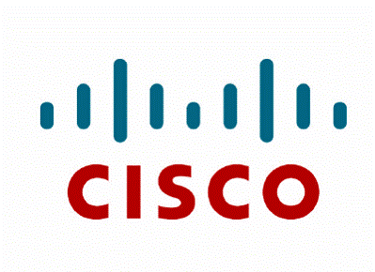

Shares.cisco.com User Guide for Clock Signal Data Customers

Version: 1.0.0

Contents

Purpose 3

Logging In 3

Aspera Connect Client Installation 6

Using the shares.cisco.com Web Application 7

Configuring User Preferences 9

Browsing Shares 14

Searching Nodes and Shares 16

Transferring Content Between Shares 18

Configuring the Connect Client for Encrypted File Transfers 20

Transferring Files 23

File Encryption 28

# 

# Purpose



The purpose of this document is to provide Cisco Customers who are participating in the Clock Signal Component Program with the necessary information needed to transfer files to shares.cisco.com. This method allows for automatic encryption/decryption of files through the transfer process.

Note: To use this alternate method of providing your spreadsheet, please first email [clock-signal-replacement-request@cisco.com](mailto:clock-signal-replacement-request@cisco.com)  to request a data folder in [shares.cisco.com](http://shares.cisco.com) be created for you. You will need to provide the agent with your [cisco.com](http://cisco.com) user ID (not password). The Order Management (OM) Team will provide you with additional instructions for uploading your file and the link to your unique file location. Once Cisco reviews the request and validates that it is entitled for replacements, you will see the results at your unique link. The OM team will email you again when those results are available or if there are any questions during the process.

Example:

*Hello Clock Signal Team,*

*I am requesting to open a case using shares.cisco.com file sharing.  Please use CCO ID xxxx to share the file.*

*Thank you.*

# Logging In



Launch your web browser and go to <https://shares.cisco.com>. Login with your cisco.com credentials.

If you do not have a cisco.com account, you will need to go to <http://www.cisco.com> and register an account.

Click on the menu button in the upper left hand corner of the window to open the side panel indicated by the red arrow in the picture below.

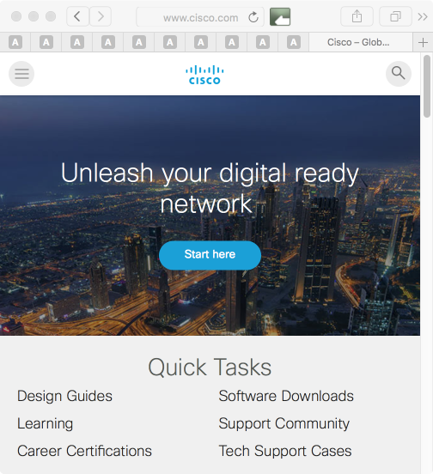

After you have opened the side panel, click on the link to register an account as indicated by the red circle below. Once you’ve registered your account you should be able to login to shares.cisco.com, however, it may take up to 30 minutes for the account to become active. If you still can’t login after 30 minutes notify component-questions@cisco.com.

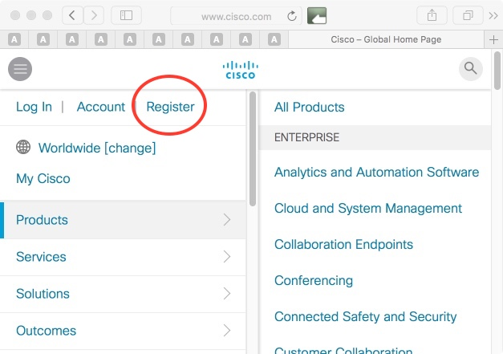

# Aspera Connect Client Installation



When you login to shares.cisco.com for the first time you will be prompted to install the Aspera Connect Client browser plugin. The Aspera Connect Client is required to perform file transfers. In the image below you can see the Aspera Connect Client installation prompt at the top of the browser window.

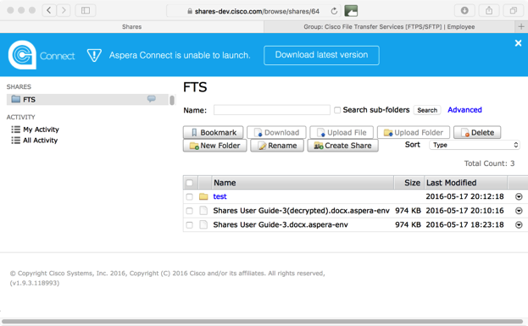

# Using the shares.cisco.com Web Application



When you first login you will not see any shares until the manager of the Clock Signal Data share authorizes you to have access to it. The image below shows that there are no shares under “SHARES” on the left of the page.

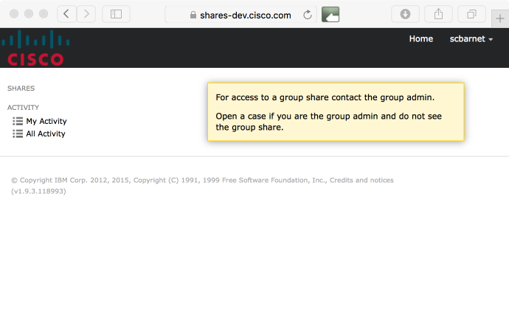

When you are granted access to the “Clock Signal Data” share, it will appear under “SHARES” as seen below.

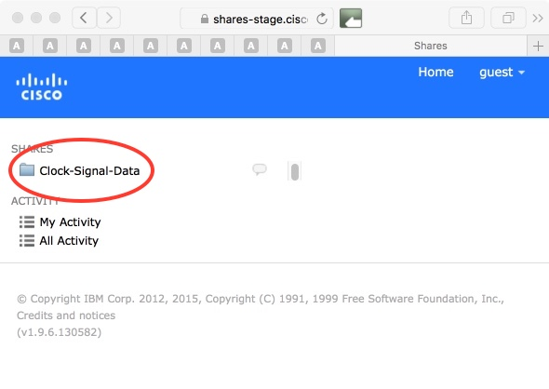

As you navigate through the Shares web UI, each page will check for the presence of the Aspera Connect browser plugin. If the plugin is not present, you will see a message to download the plugin. Changing the value of this option from the default "false" to "true" in the user preferences will stop the message from appearing.

# Configuring User Preferences



To configure your account settings, select your username in the top right corner and select **Preferences.**

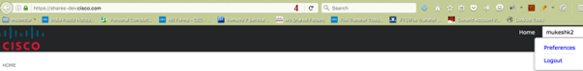

This will allow you to change your email notification options, configure your system display, and choose to suppress the Aspera Connect install dialog.

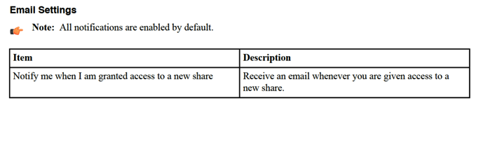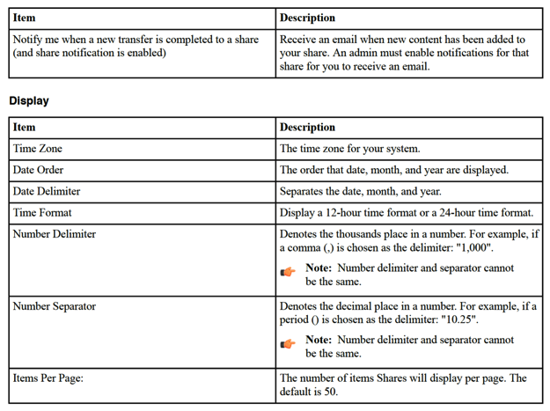

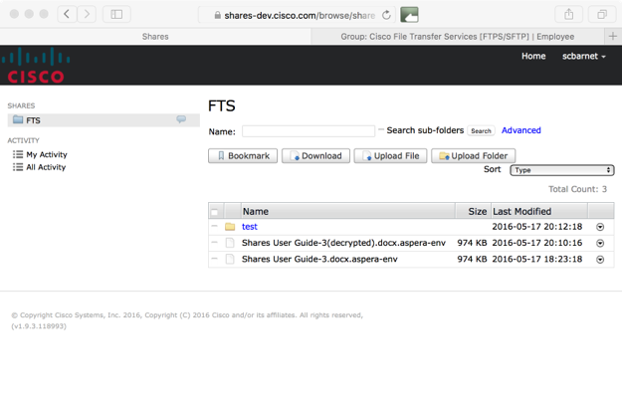

In the image above, the user has been granted browse, upload and download permissions as indicated by the buttons that are visible. NOTE: Users for the clock signal component issue will be granted only upload and download permissions.

Use the drop-down menu to the right of the share name to browse, view activity, make comments, and choose notification options as indicated below.

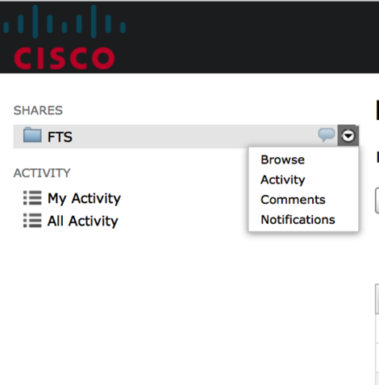

These drop-down options are described in detail below.

|  |  |
| --- | --- |
| **Function** | **Description** |
|  |  |
| Browse share | See Browsing Shares |
|  |  |
| Activity | Select **Activity** from the drop-down list to the right of the share’s name. A list of all activity that has occurred on the selected share appears. |
|  | You can also search for activity based on tagged events or a date range. |
|  |  |
|  |  |
| Comments | Select **Comments** from the drop-down list to the right of the share’s name. A list of any comments that have been made about the share appears. You can also add your own comments. |
|  |  |
|  |  |
|  |  |
| Notifications | Select **Notifications** to choose to be notified when new content has been added to your share. |
|  |  |
|  |  |
|  |  |

# 

# Browsing Shares



When you browse a share, you see all files and directories within that share.

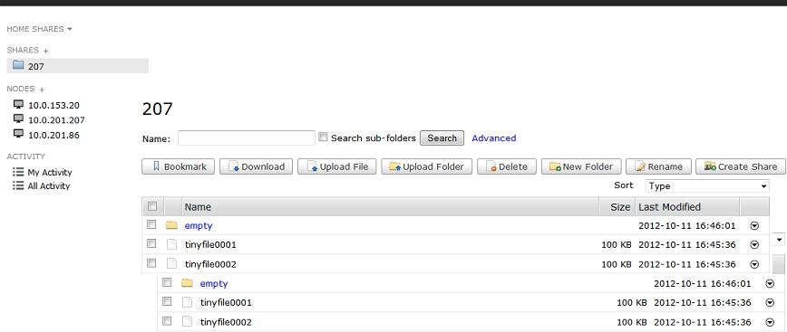

You can perform following actions on a directory or directories depending upon the permissions you have been granted:

|  |  |
| --- | --- |
| **Action** | **Description** |
|  |  |
| Bookmark | Create a shortcut to the selected directory. If you do not select any directory, the bookmark is the node’s root directory. |
|  |  |
|  |  |
| Download | Download the selected directory or directories using the Aspera® Connect™ browser plugin. |
|  |  |
|  |  |
| Upload | Upload a file or folder from another machine to this node using the Aspera Connect browser plugin. |
|  |  |
|  |  |
| Delete | Delete the selected directory or directories. |
|  |  |
| New Folder | Create a new directory on the node. |
|  |  |
| Rename | Rename an existing directory on the node. |
|  |  |
| Create Share | Create a share for the selected directory. You can only select one directory at a time. Click **Create Share** to open the **New Share** dialog. This dialog is prepopulated with the node and directory information. To complete the other fields, you must be an administrator. |
|  |  |
|  |  |
|  |  |
|  |  |

# Searching Nodes and Shares



You can perform simple or advanced searches in your shares.

To perform a search on a share or node, select a share or node on your **Home** page, then within the **Name:** box, enter a keyword for your search. You can also enable or disable the **Search sub-folders option**. Shares appends any keyword that you enter with “*”. Therefore, if you enter the keyword "Dec", the search will return any string that contains this word.

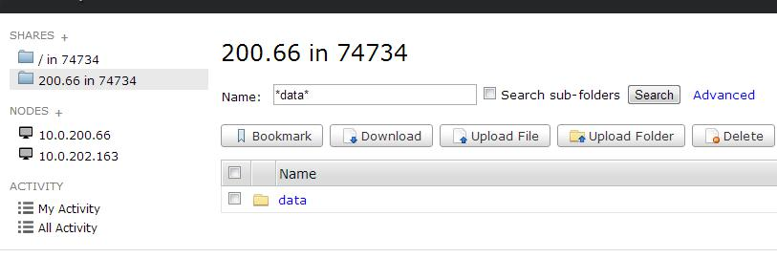

To perform a keyword search and limit the number of results, use **Advanced** search. You can set the following filters:

**Size** - Enter minimum or maximum values. Include the unit of measure as bytes, MB, or GB.

**Last Modified** - Enter from date or to date. Select a date from the popup calendar.

# Transferring Files



To download a file, you can select the check box and click the download button. You can also click the arrow for the drop down on the far right of the file name to use the drop down for the file transfer.

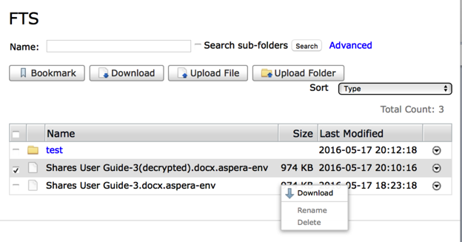

To upload a file, click the upload file or upload folder button. This will bring up a window that allows you to select files or folders from your local file system to the shares.cisco.com. PLEASE BE SURE TO CREATE A UNIQUE NAME FOR YOUR FILE SO AS TO PREVENT IT FROM BEING CONFUSED WITH ANY OTHER CUSTOMER. PLEASE USE YOUR COMPANY NAME AND BE SURE TO REPLACE THE DEFAULT TITLE.

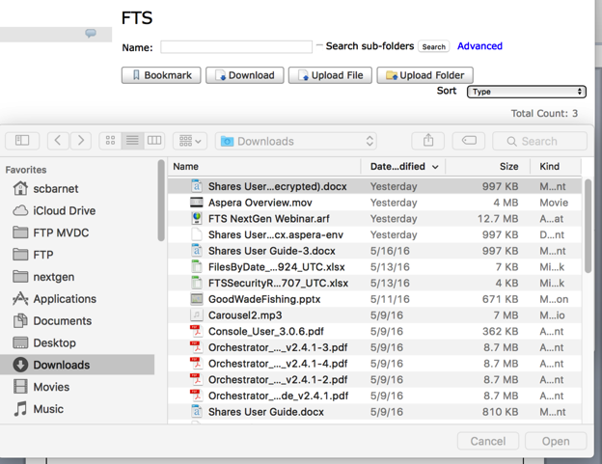

When a transfer is initiated the “Transfers” window will open as seen in the image below. Here you can see the details of the transfer.

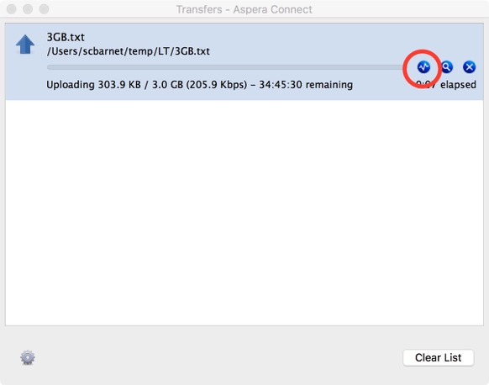

In the image above, clicking on the first blue button (circled in red) in the Aspera Connect Client window will open the Transfer Monitor window that you see in the image below. The Transfer Monitor window allows you to modify the bandwidth for the transfer. Clicking the blue magnifying glass button will show the location of the file after it’s been downloaded. You can stop/restart the transfer using the blue “x” button.

NOTE - If the transfer seems slow and you see “HTTPS” in the window above then the transfer is using “HTTPS Fallback” mode. This means the TCP/ UDP port 33001 is being blocked and the transfer is using HTTPS.

In this case, you should request that the network administrator open TCP **AND** UDP port 33001. Both TCP and UDP 33001 must be open to allow the FASP high-speed transfer to work.

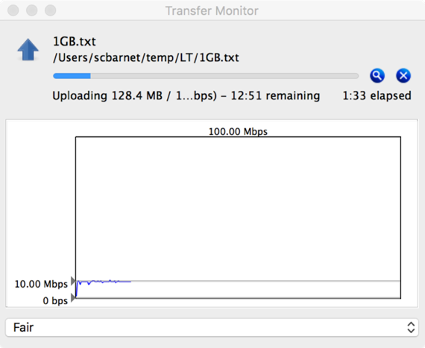

As you can see in the image above, the initial transfer rate is 10.00 Mbps, which is the default transfer speed set by the server. You can slide the arrow up if you wish to increase the bandwidth allowed for the transfer.

In the image below, the transfer limit has been raised from the default 10.00 Mbps to 90.53 Mbps. This allowed the transfer to speed up to 78.86 Mbps. During the transfer the bandwidth usage will fluctuate according to the available bandwidth on the network.

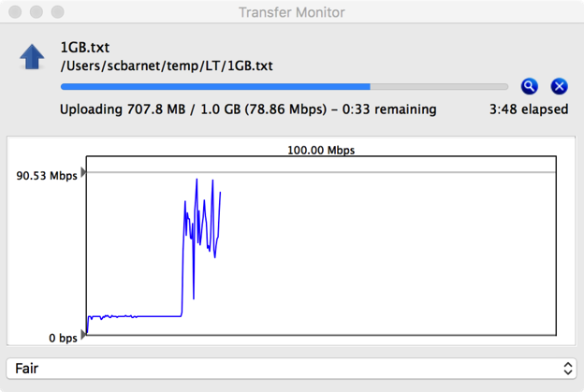

You can also decrease the bandwidth allocated for the transfer if you need to have bandwidth available for other processes that are running at the same time like video streaming, webex, VOIP, etc.

*********END************