Cisco Unity connection: ciscocm.cuc_11.5SU1_pre_upgrade.cop.sgn COP

Release Notes Version 1.2
Revised March, 2017

NOTE: This is a pre-upgrade cop file and must be installed prior to initiating upgrade for 11.5.1SU1, please read the complete document before proceeding with Upgrade to 11.5 SU1.

This COP should be installed as per instructions during Install and Upgrade procedure.
Description: This COP file addresses defect CSCvb02774.
Following steps has been done as part of the COP file -
- Disable Constraint fk_tbl_subscribertimelastcall_subscriberobjectid_tbl_usersub on the Publisher. It is required to create Admin Users entries in to tbl_subscribertimelastcall.
- Disable the same constraint on Subscriber, in case of cluster.
- Create Admin Users entries in to tbl_subscribertimelastcall.

Introduction: This release note contains important information about installation procedure for the ciscocm.cuc_11.5SU1_pre_upgrade.cop.sgn for Cisco Unity Connection.
Caution: CCM/CUC replication may be impacted during the COP installation if replication has not been established or is in progress. Make sure that replication is established both for CUC and CUCM Informix servers. To check the replication status execute below CLI’s:
“show cuc cluster status” : To check CUC replication state
Following is the ideal output for above CLI:
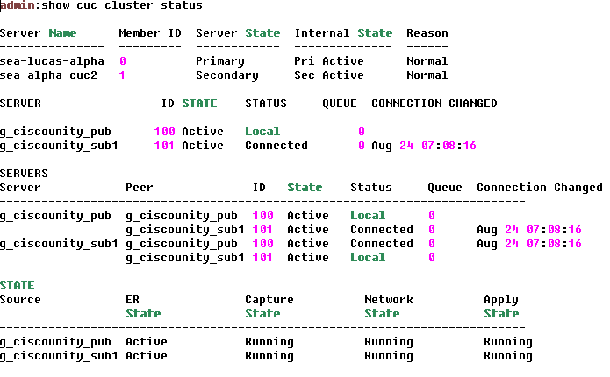

“utils dbreplication runtimestate” : To check CUCM replication state
Following is the ideal output for above CLI:
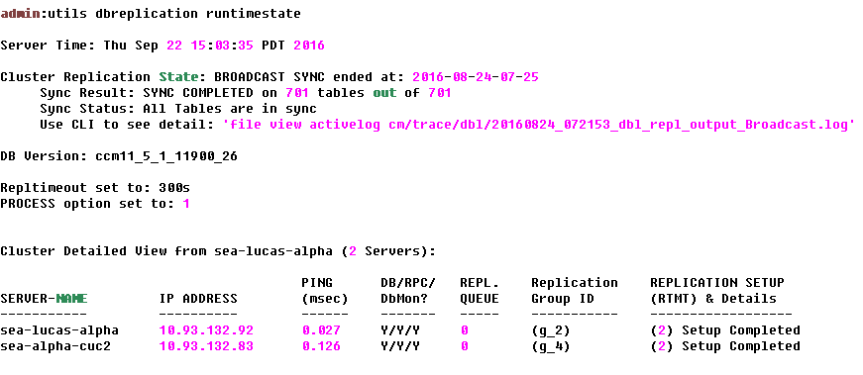

If observed any DB replication issue, need to repair it before proceeding to upgrade.

Upgrade Procedure of 11.5 SU1 to include COP file during Upgrade

Before initiating Upgrade to 11.5 SU1, install the COP file using below procedure section on the Publisher node.

NOTE:
- Above procedure will be applicable for both RU Upgrade Process (from 8.x, 9.x to 11.5SU1) & L2 Upgrade Process (from 10.x, 11.x to 11.5 SU1).
- As with any installation or upgrade, it is recommended to apply this update during off peak hours.
- No system reboot or service restart is required after installing this patch.
- COP needs to be installed on PUB only.
- Fresh install of 11.5 SU1 will not require this COP installation.
- Do not execute “run cuc preupgrade test” CLI command after installing the COP.

COP file Install Procedure

This patch can be installed from a local source (DVD) or remote source (SFTP SERVER).

Caution: Make sure to back up system data before starting the software upgrade process. For more information, see the Disaster Recovery System Administration Guide.

From Local Source:

Step1: Download ciscocm.cuc_11.5SU1_pre_upgrade.cop.sgn

Step 2: Copy the upgrade file above to a writeable CD or DVD.

Step 3: Insert the CD or DVD into the disc drive on the local server on which patch need to be installed. Step 4: Open Cisco Unified Communications Operating System Administration directly by entering the following URL: http://server-name/cmplatform, where server-name is the host name or IP address of the server.
Step 5: Enter OS Administrator username and password.

Step 6: Choose Software Upgrades > Install/Upgrade.

Step 7: For the software location source, choose DVD/CD.

Step 8: If patch file is burned to a subdirectory on the CD or DVD, enter the path in the directory field.

Step 9: To continue the upgrade process, click next.

Step 10: Choose ciscocm.cuc_11.5SU1_pre_upgrade.cop.sgn and click next.

Step 11: In the next window, monitor the progress of the download, which includes the filename and the number of megabytes that is getting transferred.
MD5= 56345e9ab7c7a877ed3cea4e858d66e9
Step 12: When the download completes, click next to proceed with the software upgrade.

Step 13: A Warning window displays the selected option, click Install.

Step 14: The Install Status window displays the Install log,

Step 15: when the installation completes, click Finish

Step 16: Verify the COP file version using this command from the CLI:

admin: show version active
Active Master Version: 10.5.xxxx
Active Version Installed Software Options:
ciscocm.cuc_11.5SU1_pre_upgrade.cop.sgn

From Remote Source:

Step 1: Download ciscocm.cuc_11.5SU1_pre_upgrade.cop.sgn

Step 2: Copy the upgrade file to an ftp or SFTP server.

Step 3: Open Cisco Unified Communications Operating System Administration directly by entering the following URL: http://server-name/cmplatform, where server-name is the host name or IP address of the server.
Step 4: Enter OS Administrator username and password.

Step 5: Choose Software Upgrades > Install/Upgrade.

Step 6: For the software location source, choose Remote File System.

Step 7: Enter the directory name for the software upgrade, if required. If the upgrade file is located on a Linux or UNIX server, then enter a forward slash at the beginning of the directory path. For example, if the upgrade file is in the patches directory, enter /patches. If the upgrade file is located on a Windows server, check with system administrator for the correct directory path.
Step 8: Enter the required upgrade information as described in the following table:

Remote Server: Host name or IP address of the remote server from which software will be downloaded.
Remote User: Enter admin user id of remote server.

Remote Password: Enter password of admin user remote server. Download Protocol: Choose SFTP or ftp.
Step 9: To continue the upgrade process, click next.

Step 10: Choose ciscocm.cuc_11.5SU1_pre_upgrade.cop.sgn and click next.

Step 11: In the next window, monitor the progress of the download, which includes the filename and the number of megabytes that are getting transferred.
MD5= 56345e9ab7c7a877ed3cea4e858d66e9

Step 13: When the download completes, click next to proceed with the software upgrade. A Warning window displays the selected option.
Step 14: Click Install.

The Install Status window displays and displays the install log.

Step 15: When the installation completes, click Finish

Step 16: Verify the COP file version using this command from the CLI:

admin: show version active
Active Master Version: 10.5.xxxx
Active Version Installed Software Options:
ciscocm.cuc_11.5SU1_pre_upgrade.cop.sgn

