Date: 2014-02-12
Name of Product: WebEx Meetings v3.5 for BlackBerry
Contact for more Information: accessibility@cisco.com
The following testing was done on BlackBerry Q10 (hardware keyboard), OS v10.2.1, screen magnifier active, font size set to 11
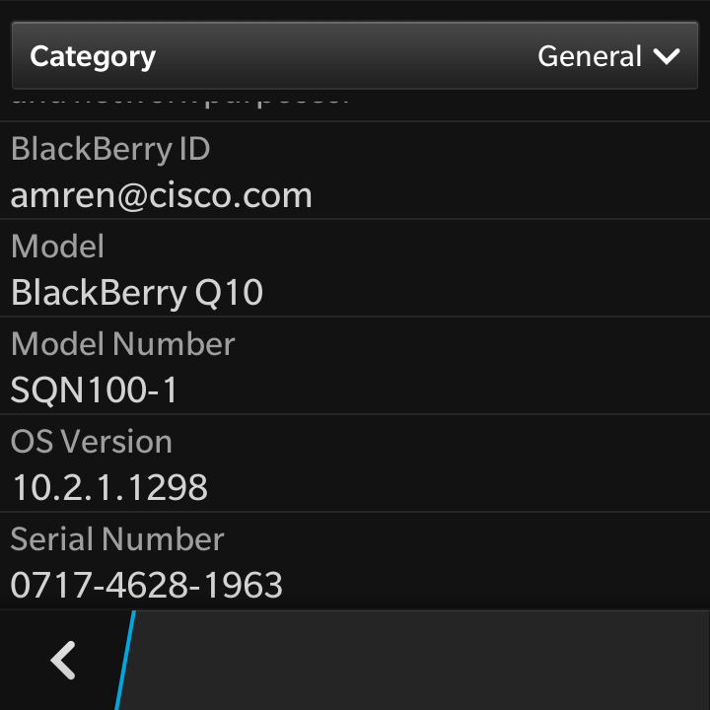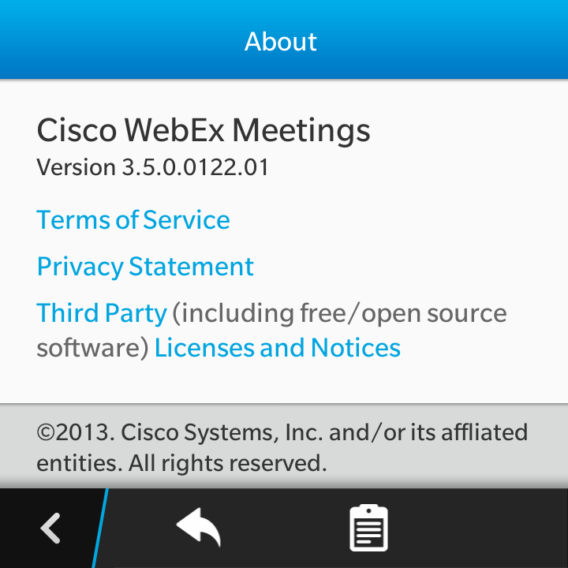

Summary Table - Voluntary Product Accessibility Template
Criteria | Supporting Features | Remarks and Explanations
Section 1194.21 Software Applications and Operating Systems | Included | Mobile access to WebEx Meetings incorporating voice, IM, and screen sharing.
Section 1194.22 Web-based internet information and applications | Not Applicable
Section 1194.23 Telecommunications Products | Not Applicable
Section 1194.24 Video and Multi-media Products | Not Applicable
Section 1194.25 Self-Contained, Closed Products | Not Applicable
Section 1194.26 Desktop and Portable Computers | Not Applicable
Section 1194.31 Functional Performance Criteria | Included
Section 1194.41 Information, Documentation and Support - Detail | Included
Section 1194.21: Software Applications and Operating Systems – Detail
WebEx Meetings v2.2, mobile meetings access
508 Clause | Criteria | Supporting Features | Remarks and Explanations
1194.21(a) | When software is designed to run on a system that has a keyboard, product functions shall be executable from a keyboard where the function itself or the result of performing a function can be discerned textually. | Supports with exceptions | Keyboard shortcuts to some menu options
1194.21(b) | Applications shall not disrupt or disable activated features of other products that are identified as accessibility features, where those features are developed and documented according to industry standards. Applications also shall not disrupt or disable activated features of any operating system that are identified as accessibility features where the application programming interface for those accessibility features has been documented by the manufacturer of the operating system and is available to the product developer. | Supports with exceptions | Does not interfere with text size and screen magnification options in Blackberry OS except app will control font size for audio and video dialog and some meeting info text. Otherwise layout will be disrupted.
1194.21(c) | A well-defined on-screen indication of the current focus shall be provided that moves among interactive interface elements as the input focus changes. The focus shall be programmatically exposed so that Assistive Technology can track focus and focus changes. | Supports with Exceptions | Some screens have an initial focus object, but application does not fully support the use of screen reader assistive technology.
1194.21(d) | Sufficient information about a user interface element including the identity, operation and state of the element shall be available to Assistive Technology. When an image represents a program element, the information conveyed by the image must also be available in text. | Does Not Support | Images in the app do not all have a text description. Icons in the app bar all have descriptions. Images/buttons not in the action bar are no longer clickable with screen reader on.
1194.21(e) | When bitmap images are used to identify controls, status indicators, or other programmatic elements, the meaning assigned to those images shall be consistent throughout an application's performance. | Supports
1194.21(f) | Textual information shall be provided through operating system functions for displaying text. The minimum information that shall be made available is text content, text input caret location, and text attributes. | Supports with Exceptions | Application is not fully compatible with screen reader assistive technology.
1194.21(g) | Applications shall not override user selected contrast and color selections and other individual display attributes. | Supports with exceptions | Font sizes greater than 11 disrupt layout but it is still useable.
1194.21(h) | When animation is displayed, the information shall be displayable in at least one non-animated presentation mode at the option of the user. | Supports | No animation features
1194.21(i) | Color coding shall not be used as the only means of conveying information, indicating an action, prompting a response, or distinguishing a visual element. | Supports
1194.21(j) | When a product permits a user to adjust color and contrast settings, a variety of color selections capable of producing a range of contrast levels shall be provided. | Dependency | No color theming supported by operating system. Application does not provide color options.
1194.21(k) | Software shall not use flashing or blinking text, objects, or other elements having a flash or blink frequency greater than 2 Hz and lower than 55 Hz. | Supports
1194.21(l) | When electronic forms are used, the form shall allow people using Assistive Technology to access the information, field elements, and functionality required for completion and submission of the form, including all directions and cues. | Does Not Support | Application is not fully compatible with screen reader assistive technology.

Section 1194.31: Functional Performance Criteria - Detail
508 Clause | Criteria | Supporting Features | Remarks and Explanations
1194.31(a) | At least one mode of operation and information retrieval that does not require user vision shall be provided, or support for Assistive Technology used by people who are blind or visually impaired shall be provided. | Does Not Support | App is not fully functional with screen reader assistive technology. Images/buttons not in the action bar are no longer clickable with screen reader on.
1194.31(b) | At least one mode of operation and information retrieval that does not require visual acuity greater than 20/70 shall be provided in audio and enlarged print output working together or independently, or support for Assistive Technology used by people who are visually impaired shall be provided. | Supports with exceptions | Increasing text size is the only available accessibility feature. No screen reader technology is supported by operating system at this time.
1194.31(c) | At least one mode of operation and information retrieval that does not require user hearing shall be provided, or support for Assistive Technology used by people who are deaf or hard of hearing shall be provided | Supports | No audio alerts in this app. BlackBerry is compatible with TTY assistive technology.
1194.31(d) | Where audio information is important for the use of a product, at least one mode of operation and information retrieval shall be provided in an enhanced auditory fashion, or support for assistive hearing devices shall be provided. | Supports with exceptions | Operating system supports TTY
1194.31(e) | At least one mode of operation and information retrieval that does not require user speech shall be provided, or support for Assistive Technology used by people with disabilities shall be provided. | Supports | No speech required to use this app.
1194.31(f) | At least one mode of operation and information retrieval that does not require fine motor control or simultaneous actions and that is operable with limited reach and strength shall be provided. | Supports with exceptions | Multiple simultaneous keystrokes not required, some keyboard support.

Section 1194.41: Information, Documentation and Support
508 Clause | Criteria | Supporting Features | Remarks and Explanations
1194.41(a) | Product support documentation provided to end-users shall be made available in alternate formats upon request, at no additional charge | Supports | Accessible documentation is available through Cisco TAC upon request.
1194.41(b) | End-users shall have access to a description of the accessibility and compatibility features of products in alternate formats or alternate methods upon request, at no additional charge. | Supports | Accessible documentation is available through Cisco TAC upon request.
1194.41(c) | Support services for products shall accommodate the communication needs of end-users with disabilities. | Supports | Cisco conforms through equal facilitation. Customers may reach Cisco Technical Assistance Center (TAC) via Phone, Email or Web Form. All cases open through email or web are opened as Priority 3 cases. All Priority 1 or Priority 2 case can only be opened via the telephone. TTY users must call the Text Relay Service (TRS) by dialing 711 or their state Video Relay Service (VRS) and have the TRS agent contact Cisco TAC via voice.

