Date: November 6, 2013
Name of Product: Cisco Prime Service Catalog, version 10.0
Contact for more Information: accessibility@cisco.com

Application Login Page:

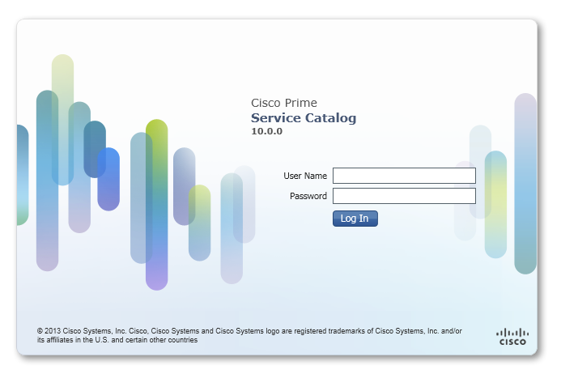
Summary Table - Voluntary Product Accessibility Template
Criteria | Supporting Features | Remarks and Explanations
Section 1194.21 Software Applications and Operating Systems | Not Applicable
Section 1194.22 Web-based internet information and applications | Included
W3C WCAG 2.0 Level “A” Checkpoints | Included
Section 1194.23 Telecommunications Products | Not Applicable
Section 1194.24 Video and Multi-media Products | Not Applicable
Section 1194.25 Self-Contained, Closed Products | Not Applicable
Section 1194.26 Desktop and Portable Computers | Not Applicable
Section 1194.31 Functional Performance Criteria | Included
Section 1194.41 Information, Documentation and Support - Detail | Included

Section 1194.22 Web-based internet information and applications – Detail

Cisco Prime Service Catalog, version 10.0
508 Clause | Criteria | Status | Remarks and Explanations
1194.22(a) | A text equivalent for every non-text element shall be provided (e.g., via "alt", "longdesc", or in element content). | Supports with Exceptions | Some non-text content is not fully supported with screen reader software, including some images.
1194.22(b) | Equivalent alternatives for any multimedia presentation shall be synchronized with the presentation. | Not Applicable | No instances of multimedia content.
1194.22(c) | Web pages shall be designed so that all information conveyed with color is also available without color, for example from context or markup. | Supports
1194.22(d) | Documents shall be organized so they are readable without requiring an associated style sheet. | Supports with Exceptions | Equivalent Facilitation is provided for low-vision users in high-contrast schemes from the OS; however some buttons are not fully readable and usable.
1194.22(e) | Redundant text links shall be provided for each active region of a server-side image map. | Not Applicable | No instances of server-side image maps.
1194.22(f) | Client-side image maps shall be provided instead of server-side image maps except where the regions cannot be defined with an available geometric shape. | Not Applicable | No instances of client-side image maps
1194.22(g) | Row and column headers shall be identified for data tables. | Supports with Exceptions | Some data tables are not fully supported with screen reader software.
1194.22(h) | Markup shall be used to associate data cells and header cells for data tables that have two or more logical levels of row or column headers. | Not Applicable | No instances of data tables with two or more logical levels of row or column headers.
1194.22(i) | Frames shall be titled with text that facilitates frame identification and navigation. | Supports | iFrames have proper titles.
1194.22(j) | Pages shall be designed to avoid causing the screen to flicker with a frequency greater than 2 Hz and lower than 55 Hz. | Not Applicable | No instances of blinking or flashing that is  within the danger range of 2Hz to 55Hz.
1194.22(k) | A text-only page, with equivalent information or functionality, shall be provided to make a web site comply with the provisions of this part, when compliance cannot be accomplished in any other way. The content of the text-only page shall be updated whenever the primary page changes. | Does Not Support | Text-only page is not provided.
1194.22(l) | When pages utilize scripting languages to display content, or to create interface elements, the information provided by the script shall be identified with functional text that can be read by assistive technology. | Supports with Exceptions | Some web pages are not fully supported with keyboard navigation and screen reader software.
1194.22(m) | When a web page requires that an applet, plug-in or other application be present on the client system to interpret page content, the page must provide a link to a plug-in or applet that complies with §1194.21(a) through (l). | Not Applicable | The application does not use applet or plug-in content
1194.22(n) | When electronic forms are designed to be completed on-line, the form shall allow people using assistive technology to access the information, field elements, and functionality required for completion and submission of the form, including all directions and cues. | Supports with Exceptions | Some forms are not fully supported with screen reader software.
1194.22(o) | A method shall be provided that permits users to skip repetitive navigation links. | Not Applicable | Menu and/or tab containers are used to navigate the application, no repetitive navigation links.
1194.22(p) | When a timed response is required, the user shall be alerted and given sufficient time to indicate more time is required. | Not Applicable | No instances of timed response in this application.

W3C WCAG 2.0 Level “A” Checkpoints – Detail
Cisco Prime Service Catalog, version 10.0
Checkpoint | Description | Status | Comments
1.1.1 | Non text content | Supports with Exceptions | Some non-text content is not fully supported with screen reader software, including some images.
1.2.1 | Audio-only and Video-only (Prerecorded) | Not Applicable
1.2.2 | Captions (Prerecorded) | Not Applicable
1.2.3 | Audio Description or Media Alternative (Prerecorded) | Not Applicable
1.3.1 | Info and Relationships | Supports with Exceptions | Some forms and data tables are not fully supported with screen reader software.
1.3.2 | Meaningful Sequence | Supports
1.3.3 | Sensory Characteristics | Not Applicable
1.4.1 | Use of Color | Supports
1.4.2 | Audio Control | Not Applicable
1.4.3 | Contrast | Supports with Exceptions | In high contrast modes, some buttons no longer visible.
2.1.1 | Keyboard | Supports with Exceptions | Not all focusable elements are included in a logical tab order and accessible via keyboard-only navigation.
2.1.2 | No Keyboard Trap | Supports
2.2.1 | Timing Adjustable | Not Applicable
2.2.2 | Pause, Stop, Hide | Not Applicable
2.3.1 | Three Flashes or Below Threshold | Not Applicable
2.4.1 | Bypass Blocks | Not Applicable
2.4.2 | Page Titled | Supports
2.4.3 | Focus Order | Supports with Exceptions | For some pages, not all focusable elements are included in a logical tab order.
2.4.4 | Link Purpose (In Context) | Supports
3.1.1 | Language of Page | Supports with Exceptions | The LANG attribute is not always set to one of the ISO 639 language codes.
3.2.1 | On Focus | Supports
3.2.2 | On Input | Supports
3.3.1 | Error Identification | Supports
3.3.2 | Labels or Instructions | Supports with Exceptions | Some forms are not labeled correctly.
4.1.1 | Parsing | Supports with Exceptions | Some elements use duplicate ID.
4.1.2 | Name, Role, Value | Supports with Exceptions | Name, Role, and Value attributes are not set for some widgets.

Section 1194.31: Functional Performance Criteria - Detail
508 Clause | Criteria | Supporting Features | Remarks and Explanations
1194.31(a) | At least one mode of operation and information retrieval that does not require user vision shall be provided, or support for Assistive Technology used by people who are blind or visually impaired shall be provided. | Supports with Exceptions | Overall there are some exceptions in keyboard navigation, electronic forms, and compatibility with Assistive Technology. See comments in WCAG 2.0 and 1194.22.
1194.31(b) | At least one mode of operation and information retrieval that does not require visual acuity greater than 20/70 shall be provided in audio and enlarged print output working together or independently, or support for Assistive Technology used by people who are visually impaired shall be provided. | Supports with Exceptions | Overall there are minor exceptions for person with low vision impairment and compatibility with Assistive Technology. See comments in WCAG 2.0 and 1194.22
1194.31(c) | At least one mode of operation and information retrieval that does not require user hearing shall be provided, or support for Assistive Technology used by people who are deaf or hard of hearing shall be provided | Supports | Video and audio content can be accessed through the portal, but is not within the framework of the portal. It does not have a video or audio player and is dependent on whether the customer’s content provides Captioning or transcripts.
1194.31(d) | Where audio information is important for the use of a product, at least one mode of operation and information retrieval shall be provided in an enhanced auditory fashion, or support for assistive hearing devices shall be provided. | Supports | There are not instances of audio features in this product.
1194.31(e) | At least one mode of operation and information retrieval that does not require user speech shall be provided, or support for Assistive Technology used by people with disabilities shall be provided. | Supports | There are not instances that require user speech in this product.
1194.31(f) | At least one mode of operation and information retrieval that does not require fine motor control or simultaneous actions and that is operable with limited reach and strength shall be provided. | Supports with Exceptions | Overall there are some exceptions in keyboard navigation, electronic forms, and compatibility with Assistive Technology. See comments in WCAG 2.0 and 1194.22.  There are not instances of simultaneous actions.

Section 1194.41: Information, Documentation and Support
508 Clause | Criteria | Supporting Features | Remarks and Explanations
1194.41(a) | Product support documentation provided to end-users shall be made available in alternate formats upon request, at no additional charge | Supports | Accessible documentation is available through Cisco TAC upon request.
1194.41(b) | End-users shall have access to a description of the accessibility and compatibility features of products in alternate formats or alternate methods upon request, at no additional charge. | Supports | Accessible documentation is available through Cisco TAC upon request.
1194.41(c) | Support services for products shall accommodate the communication needs of end-users with disabilities. | Supports | Cisco conforms through equal facilitation. Customers may reach Cisco Technical Assistance Center (TAC) via Phone, Email or Web Form. All cases open through email or web are opened as Priority 3 cases. All Priority 1 or Priority 2 case can only be opened via the telephone. TTY users must call the Text Relay Service (TRS) by dialing 711 and have the TRS agent contact Cisco TAC via voice.

