Date: November 25, 2013
Name of Product: MediaSense Search & Play Application, version 10.0
Contact for more information: accessibility@cisco.com
The following testing was done on a Windows 7 with Firefox 23.0.1, Freedom Scientific’s JAWs screen reader 14.0.1534 on FF 23.0.1, and standard Keyboard.

Summary Table - Voluntary Product Accessibility Template
Criteria | Supporting Features | Remarks and Explanations
Section 1194.21 Software Applications and Operating Systems | Not Applicable
Section 1194.22 Web-based internet information and applications | Included
W3C WCAG 2.0 Level “A” Checkpoints | Included
Section 1194.23 Telecommunications Products | Not Applicable
Section 1194.24 Video and Multi-media Products | Not Applicable
Section 1194.25 Self-Contained, Closed Products | Not Applicable
Section 1194.26 Desktop and Portable Computers | Not Applicable
Section 1194.31 Functional Performance Criteria | Included
Section 1194.41 Information, Documentation and Support | Included

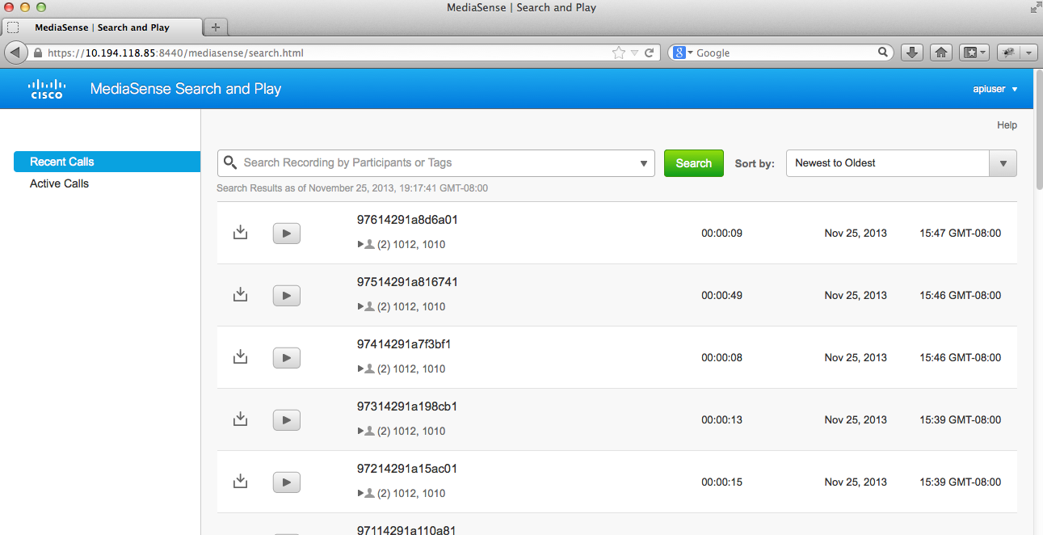
Section 1194.22 Web-based internet information and applications – Detail
508 Clause | Criteria | Status | Remarks and Explanations
1194.22(a) | A text equivalent for every non-text element shall be provided (e.g., via "alt", "longdesc", or in element content). | Supports with Exceptions | LONGDESC (Long description) file not applicable.  ASCII art, emoticons and leetspeak not included in product.  Long description for non-text content not applicable.  CAPTCHA not applicable.
1194.22(b) | Equivalent alternatives for any multimedia presentation shall be synchronized with the presentation. | Not Applicable
1194.22(c) | Web pages shall be designed so that all information conveyed with color is also available without color, for example from context or markup. | Supports
1194.22(d) | Documents shall be organized so they are readable without requiring an associated style sheet. | Supports with Exceptions | LABEL and TITLE supported; all other table techniques not applicable.  Unicode RLM and LRM, and DIR attribute not applicable.  High contrast not supported.
1194.22(e) | Redundant text links shall be provided for each active region of a server-side image map. | Not Applicable
1194.22(f) | Client-side image maps shall be provided instead of server-side image maps except where the regions cannot be defined with an available geometric shape. | Not Applicable
1194.22(g) | Row and column headers shall be identified for data tables. | Supports with Exceptions | LABEL and TITLE supported; all other table techniques not applicable.
1194.22(h) | Markup shall be used to associate data cells and header cells for data tables that have two or more logical levels of row or column headers. | Not Applicable
1194.22(i) | Frames shall be titled with text that facilitates frame identification and navigation. | Not Applicable
1194.22(j) | Pages shall be designed to avoid causing the screen to flicker with a frequency greater than 2 Hz and lower than 55 Hz. | Supports
1194.22(k) | A text-only page, with equivalent information or functionality, shall be provided to make a web site comply with the provisions of this part, when compliance cannot be accomplished in any other way. The content of the text-only page shall be updated whenever the primary page changes. | Not Applicable
1194.22(l) | When pages utilize scripting languages to display content, or to create interface elements, the information provided by the script shall be identified with functional text that can be read by assistive technology. | Supports
1194.22(m) | When a web page requires that an applet, plug-in or other application be present on the client system to interpret page content, the page must provide a link to a plug-in or applet that complies with §1194.21(a) through (l). | Supports
1194.22(n) | When electronic forms are designed to be completed on-line, the form shall allow people using assistive technology to access the information, field elements, and functionality required for completion and submission of the form, including all directions and cues. | Supports with Exceptions | LABEL and TITLE supported; all other table techniques not applicable.
1194.22(o) | A method shall be provided that permits users to skip repetitive navigation links. | Not Applicable
1194.22(p) | When a timed response is required, the user shall be alerted and given sufficient time to indicate more time is required. | Supports

W3C WCAG 2.0 Level “A” Checkpoints – Detail
Checkpoint | Description | Status | Remarks and Explanations
1.1.1 | Non text content | Supports with Exceptions | LONGDESC (Long description) file not applicable.  ASCII art, emoticons and leetspeak not included in product.  Long description for non-text content not applicable.  CAPTCHA not applicable.
1.2.1 | Audio-only and Video-only (Prerecorded) | Not Applicable
1.2.2 | Captions (Prerecorded) | Not Applicable
1.2.3 | Audio Description or Media Alternative (Prerecorded) | Not Applicable
1.3.1 | Info and Relationships | Supports with Exceptions | LABEL and TITLE supported; all other table techniques not applicable.
1.3.2 | Meaningful Sequence | Supports with Exceptions | Unicode RLM and LRM, and DIR attribute not applicable.
1.3.3 | Sensory Characteristics | Not Applicable
1.4.1 | Use of Color | Not Applicable
1.4.2 | Audio Control | Not Applicable
1.4.3 | Contrast | Supports with Exceptions | High contrast not supported.
2.1.1 | Keyboard | Supports
2.1.2 | No Keyboard Trap | Supports
2.2.1 | Timing Adjustable | Not Applicable
2.2.2 | Pause, Stop, Hide | Not Applicable
2.3.1 | Three Flashes or Below Threshold | Not Applicable
2.4.1 | Bypass Blocks | Not Applicable
2.4.2 | Page Titled | Supports
2.4.3 | Focus Order | Supports
2.4.4 | Link Purpose (In Context) | Supports
3.1.1 | Language of Page | Supports
3.2.1 | On Focus | Supports
3.2.2 | On Input | Supports
3.3.1 | Error Identification | Supports
3.3.2 | Labels or Instructions | Supports
4.1.1 | Parsing | Supports
4.1.2 | Name, Role, Value | Supports with Exceptions | Names and roles not applicable.

Section 1194.31: Functional Performance Criteria – Detail
508 Clause | Criteria | Supporting Features | Remarks and Explanations
1194.31(a) | At least one mode of operation and information retrieval that does not require user vision shall be provided, or support for Assistive Technology used by people who are blind or visually impaired shall be provided. | Supports with Exceptions | See Comments for WCAG 2.0: 1.1.1, 1.3.1, 1.3.2, 4.1.2
1194.31(b) | At least one mode of operation and information retrieval that does not require visual acuity greater than 20/70 shall be provided in audio and enlarged print output working together or independently, or support for Assistive Technology used by people who are visually impaired shall be provided. | Supports with Exceptions | See Comments for WCAG 2.0: 1.4.3
1194.31(c) | At least one mode of operation and information retrieval that does not require user hearing shall be provided, or support for Assistive Technology used by people who are deaf or hard of hearing shall be provided | Supports
1194.31(d) | Where audio information is important for the use of a product, at least one mode of operation and information retrieval shall be provided in an enhanced auditory fashion, or support for assistive hearing devices shall be provided. | Supports
1194.31(e) | At least one mode of operation and information retrieval that does not require user speech shall be provided, or support for Assistive Technology used by people with disabilities shall be provided. | Supports
1194.31(f) | At least one mode of operation and information retrieval that does not require fine motor control or simultaneous actions and that is operable with limited reach and strength shall be provided. | Supports with Exceptions | See Comments for WCAG 2.0: 1.1.1, 1.3.1, 1.3.2, 4.1.2

Section 1194.41: Information, Documentation and Support - Detail
508 Clause | Criteria | Supporting Features | Remarks and Explanations
1194.41(a) | Product support documentation provided to end-users shall be made available in alternate formats upon request, at no additional charge | Supports | Accessible documentation is available through Cisco TAC upon request.
1194.41(b) | End-users shall have access to a description of the accessibility and compatibility features of products in alternate formats or alternate methods upon request, at no additional charge. | Supports | Accessible documentation is available through Cisco TAC upon request.
1194.41(c) | Support services for products shall accommodate the communication needs of end-users with disabilities. | Supports | Cisco conforms through equal facilitation. Customers may reach Cisco Technical Assistance Center (TAC) via Phone, Email or Web Form. All cases open through email or web are opened as Priority 3 cases. All Priority 1 or Priority 2 case can only be opened via the telephone. TTY users must call the Text Relay Service (TRS) by dialing 711 or their state Video Relay Service (VRS) and have the TRS agent contact Cisco TAC via voice.

