Date: June 8, 2015
Name of Product: Cisco Unified Communications Manager v11.0
Contact for more information: accessibility@cisco.com
The following testing was done on a Windows 7 with Freedom Scientific’s JAWs screen reader v 14, Firefox 23.0, Microsoft Accessibility Options (Filter keys and Display/Contrast settings), and standard Keyboard.

Summary Table - Voluntary Product Accessibility Template
Criteria | Supporting Features | Remarks and Explanations
Section 1194.21 Software Applications and Operating Systems | Not Applicable
Section 1194.22 Web-based internet information and applications | Included | Web-based Administration and User Pages
W3C WCAG 2.0 Checkpoints | Included | Web-based Administration and User Pages
Section 1194.23 Telecommunications Products | Not Applicable
Section 1194.24 Video and Multi-media Products | Not Applicable
Section 1194.25 Self-Contained, Closed Products | Not Applicable
Section 1194.26 Desktop and Portable Computers | Not Applicable
Section 1194.31 Functional Performance Criteria | Included
Section 1194.41 Information, Documentation and Support | Included

Version of the Product (NOTE: minor version number subject to change from final

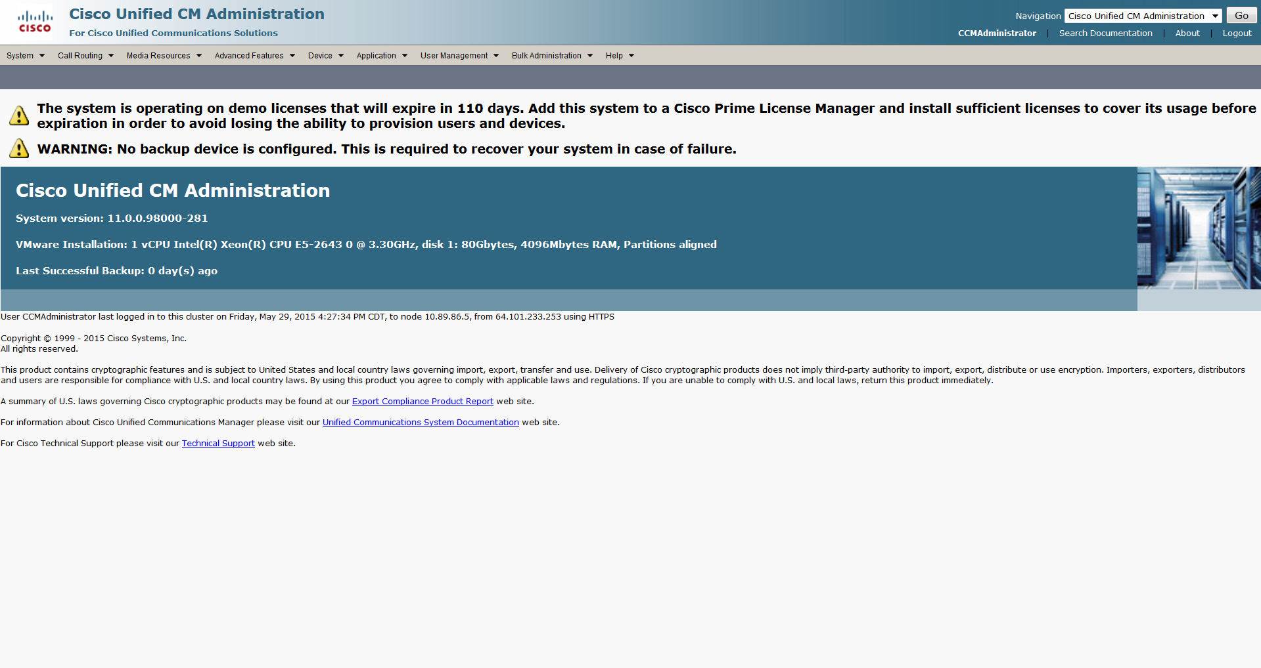

Section 1194.22 Web-based internet information and applications – Detail
508 Clause | Criteria | Status | Remarks and Explanations
1194.22(a) | A text equivalent for every non-text element shall be provided (e.g., via "alt", "longdesc", or in element content). | Supports with Exceptions | Some non-text content is not fully supported with screen reader software, including some images.
1194.22(b) | Equivalent alternatives for any multimedia presentation shall be synchronized with the presentation. | Not applicable | Web site does not use multimedia content.
1194.22(c) | Web pages shall be designed so that all information conveyed with color is also available without color, for example from context or markup. | Supports
1194.22(d) | Documents shall be organized so they are readable without requiring an associated style sheet. | Supports with Exceptions | The horizontal menu bar is dependent on CSS. Equivalent facilitation is provided to support low vision users in high contrast. The high contrast schemes cannot be used with some large text schemes. Some menu bars become nonfunctional when in high contrast mode.
1194.22(e) | Redundant text links shall be provided for each active region of a server-side image map. | Not Applicable | Web site does not use server-side image maps.
1194.22(f) | Client-side image maps shall be provided instead of server-side image maps except where the regions cannot be defined with an available geometric shape. | Not Applicable | Web site does not use client-side image maps.
1194.22(g) | Row and column headers shall be identified for data tables. | Supports with Exceptions | Some data tables are not fully supported with screen reader software. Some data tables don't have the HEADERS attribute to identify the header cells.
1194.22(h) | Markup shall be used to associate data cells and header cells for data tables that have two or more logical levels of row or column headers. | Supports with Exceptions | Some data tables are not fully supported with screen reader software.
1194.22(i) | Frames shall be titled with text that facilitates frame identification and navigation. | Supports with Exceptions | Some frames are not fully supported with screen reader software.
1194.22(j) | Pages shall be designed to avoid causing the screen to flicker with a frequency greater than 2 Hz and lower than 55 Hz. | Not Applicable | Web site does not use blinking or flickering content
1194.22(k) | A text-only page, with equivalent information or functionality, shall be provided to make a web site comply with the provisions of this part, when compliance cannot be accomplished in any other way. The content of the text-only page shall be updated whenever the primary page changes. | Does Not Support
1194.22(l) | When pages utilize scripting languages to display content, or to create interface elements, the information provided by the script shall be identified with functional text that can be read by assistive technology. | Supports with Exceptions | Some web pages are not fully supported with screen reader software.
1194.22(m) | When a web page requires that an applet, plug-in or other application be present on the client system to interpret page content, the page must provide a link to a plug-in or applet that complies with §1194.21(a) through (l). | Not Applicable | Web site does not use applet or plug-in content
1194.22(n) | When electronic forms are designed to be completed on-line, the form shall allow people using assistive technology to access the information, field elements, and functionality required for completion and submission of the form, including all directions and cues. | Supports with Exceptions | Some web pages are not fully supported with screen reader software.
1194.22(o) | A method shall be provided that permits users to skip repetitive navigation links. | Does Not Support
1194.22(p) | When a timed response is required, the user shall be alerted and given sufficient time to indicate more time is required. | Does Not Support

W3C WCAG 2.0 Checkpoints – Detail
Checkpoint | Description | Status | Remarks and Explanations
1.1.1 (A) | Non text content | Supports with Exceptions | Some non-text content is not fully supported with screen reader software, including some images.
1.2.1 (A) | Audio-only and Video-only (Prerecorded) | Not Applicable
1.2.2 (A) | Captions (Prerecorded) | Not Applicable
1.2.3 (A) | Audio Description or Media Alternative (Prerecorded) | Not Applicable
1.2.4 (AA) | Captions (Live) | Not Applicable
1.2.5 (AA) | Audio Description (Prerecorded) | Not Applicable
1.3.1 (A) | Info and Relationships | Supports with Exceptions | Some form elements and data tables are not fully supported with screen reader software.
1.3.2 (A) | Meaningful Sequence | Supports with Exceptions | When the sequence in which content is presented affects its meaning, a correct reading sequence cannot always be determined programmatically.
1.3.3 (A) | Sensory Characteristics | Not Applicable
1.4.1 (A) | Use of Color | Supports
1.4.2 (A) | Audio Control | Not Applicable
1.4.3 (AA) | Contrast (Minimum) | Supports with Exceptions | The high contrast schemes cannot be used with some large text schemes. Some menu bars become nonfunctional when in high contrast mode
1.4.4 (AA) | Resize Text | Supports
1.4.5 (AA) | Images of Text | Not Applicable
2.1.1 (A) | Keyboard | Supports with Exceptions | In some cases, the keyboard focus gets lost shortly after logging in. In these cases, the location of the focus can be tracked through a hyperlink that appears at the bottom left of the UI every time the tab key is pressed. If the user decides to choose any of these locations by pressing the enter key when that particular link appears, and returns to tabbing after the page refreshes, the focus starts at the Help tab in the menu bar and it continues through the Help menu items, then it moves to the 'Navigation" frame and its sub-links, then it disappears again.
2.1.2 (A) | No Keyboard Trap | Supports
2.2.1 (A) | Timing Adjustable | Does Not Support | The session is automatically logged out when it is not active for 30 minutes.
2.2.2 (A) | Pause, Stop, Hide | Not Applicable
2.3.1 (A) | Three Flashes or Below Threshold | Not Applicable
2.4.1 (A) | Bypass Blocks | Supports with Exceptions | Some frames are not fully supported with screen reader software.
2.4.2 (A) | Page Titled | Supports with Exceptions | Some web pages do not have title.
2.4.3 (A) | Focus Order | Supports with Exceptions | Some form elements do not maintain a logical focus order.
2.4.4 (A) | Link Purpose (In Context) | Supports
2.4.5 (AA) | Multiple Ways | Does Not Support
2.4.6 (AA) | Headings and Labels | Supports with Exceptions | Some headings are on top menu and on content section of the page there is no heading
2.4.7 (AA) | Focus Visible | Supports
3.1.1 (A) | Language of Page | Supports
3.1.2 (AA) | Language of Parts | Does not support | Language is set at document level though not at individual parts.
3.2.1 (A) | On Focus | Supports
3.2.2 (A) | On Input | Supports
3.2.3 (AA) | Consistent Navigation | Supports
3.2.4 (AA) | Consistent Identification | Supports
3.3.1 (A) | Error Identification | Supports
3.3.2 (A) | Labels or Instructions | Supports with Exceptions | Labels or instructions are not always provided when content requires user input.
3.3.3 (AA) | Error Suggestion | Supports
3.3.4 (AA) | Error Prevention (Legal, Financial, Data) | Not Applicable
4.1.1 (A) | Parsing | Supports with Exceptions | Some web pages have duplicate IDs and missing DOCTYPE statement.
4.1.2 (A) | Name, Role, Value | Supports with Exceptions | The menu bar implementation does not depict the role of the menu bar. It is a CSS/DHTML implementation that does provide keyboard navigation.

Section 1194.31: Functional Performance Criteria – Detail
508 Clause | Criteria | Supporting Features | Remarks and Explanations
1194.31(a) | At least one mode of operation and information retrieval that does not require user vision shall be provided, or support for Assistive Technology used by people who are blind or visually impaired shall be provided. | Supports with Exceptions | See remarks in 1194.22 (a)(g)(h)(i)(k)(l)(n)(o)
1194.31(b) | At least one mode of operation and information retrieval that does not require visual acuity greater than 20/70 shall be provided in audio and enlarged print output working together or independently, or support for Assistive Technology used by people who are visually impaired shall be provided. | Supports with Exceptions | See remarks in 1194.22(d)
1194.31(c) | At least one mode of operation and information retrieval that does not require user hearing shall be provided, or support for Assistive Technology used by people who are deaf or hard of hearing shall be provided | Supports
1194.31(d) | Where audio information is important for the use of a product, at least one mode of operation and information retrieval shall be provided in an enhanced auditory fashion, or support for assistive hearing devices shall be provided. | Not Applicable | There are no audio features in this product.
1194.31(e) | At least one mode of operation and information retrieval that does not require user speech shall be provided, or support for Assistive Technology used by people with disabilities shall be provided. | Supports
1194.31(f) | At least one mode of operation and information retrieval that does not require fine motor control or simultaneous actions and that is operable with limited reach and strength shall be provided. | Supports with Exceptions | See remarks in 1194.22 (a)(g)(l)(n)

Section 1194.41: Information, Documentation and Support - Detail
508 Clause | Criteria | Supporting Features | Remarks and Explanations
1194.41(a) | Product support documentation provided to end-users shall be made available in alternate formats upon request, at no additional charge | Supports | Accessible documentation is available through Cisco TAC upon request.
1194.41(b) | End-users shall have access to a description of the accessibility and compatibility features of products in alternate formats or alternate methods upon request, at no additional charge. | Supports | Accessible documentation is available through Cisco TAC upon request.
1194.41(c) | Support services for products shall accommodate the communication needs of end-users with disabilities. | Supports | Cisco conforms through equal facilitation. Customers may reach Cisco Technical Assistance Center (TAC) via Phone, Email or Web Form. All cases open through email or web are opened as Priority 3 cases. All Priority 1 or Priority 2 case can only be opened via the telephone. TTY users must call the Text Relay Service (TRS) by dialing 711 or their state Video Relay Service (VRS) and have the TRS agent contact Cisco TAC via voice.

Supporting Feature (Status) Terminology
The result of “Accessibility Testing" assists in the determination of the Supporting Features.

Supporting Features or Status
Supports | Use this language when you determine the product fully meets the letter and intent of the Criteria.
Supports with Exceptions | Use this language when you determine the product does not fully meet the letter and intent of the Criteria, but provides some level of access relative to the Criteria. Please document the exception in the “Remarks and Explanations” column.
Supports through Equivalent Facilitation | Use this language when you have identified an alternate way to meet the intent of the Criteria or when the product does not fully meet the intent of the Criteria. Please document the exception in the “Remarks and Explanations” column.
Supports when combined with Compatible Assistive Technology | Use this language when you determine the product fully meets the letter and intent of the Criteria when used in combination with Compatible Assistive Technology. For example, many software programs can provide speech output when combined with a compatible screen reader (commonly used assistive technology for people who are blind). Please document the exception in the “Remarks and Explanations” column.
Does not Support | Use this language when you determine the product does not meet the letter or intent of the Criteria. Please document the reason in the “Remarks and Explanations” column.
Not Applicable | Use this language when you determine that the Criteria do not apply to the specific product. For example, many web applications don't have video content the "Not Applicable" can be used. Please state "The application does not have any video content" in the “Remarks and Explanations” column. Please document the reason in the “Remarks and Explanations” column.

