Contents
Platform model options 3
Applications 4
Solution specifications: System capacity 7
Licensing 7
Ordering information 8
Cisco Services 8
Cisco Capital 8
For more information 8
Document history 9
Cisco Business Edition 6000 14 (Collaboration System Release Version 14) with M6 appliances
The Cisco® Business Edition 6000 (BE6000) gives employees a full range of collaboration tools: premium voice, video, messaging, instant messaging and presence, conferencing, video conferencing, contact center services, mobility capabilities, and more. With these tools your small or midsize business can boost productivity among employees and strengthen relationships with customers and business partners. And they can help you speed decision making and reduce time to market.
Cisco BE6000 is purpose-built for companies with 25 to 1000 employees. The solutions consist of one or more modular, stackable appliances so you can easily add more capacity to support additional users. And because they use virtualization technology, they pack a lot of collaboration tools into a small form factor.
Cisco BE6000 is delivered with a suite of preloaded, ready-to-activate unified communications and collaboration applications. And as your business needs grow, you can easily “turn on” the additional application options supported, including emergency services, contact center, video conferencing, edge connectivity, and more. Cisco BE6000 and Webex can be purchased together with a subscription using the Cisco Collaboration Flex Plan, which enables customers to simplify purchasing with meetings, messaging, and calling capabilities in one offer.
With these choices in size and functionality, you can select a collaboration engine that meets your business’s specific needs.
Platform model options
Cisco BE6000 platforms are built on virtualized Cisco Unified Computing System™ (Cisco UCS®) products, which are designed for performance and density over a wide range of company sizes and business workloads. There is one model. It supports multiple applications (typically five to seven) in a single virtualized server platform with a maximum capacity of 1000 users, 1200 devices, and 100 contact center agents. It is ideal for medium-scale, end-to-end collaboration deployments.
The appliances are delivered with preinstalled virtualization hypervisor and application software, ready to install and license. Specific details of BE6000 platform components are available at the links provided in following section.
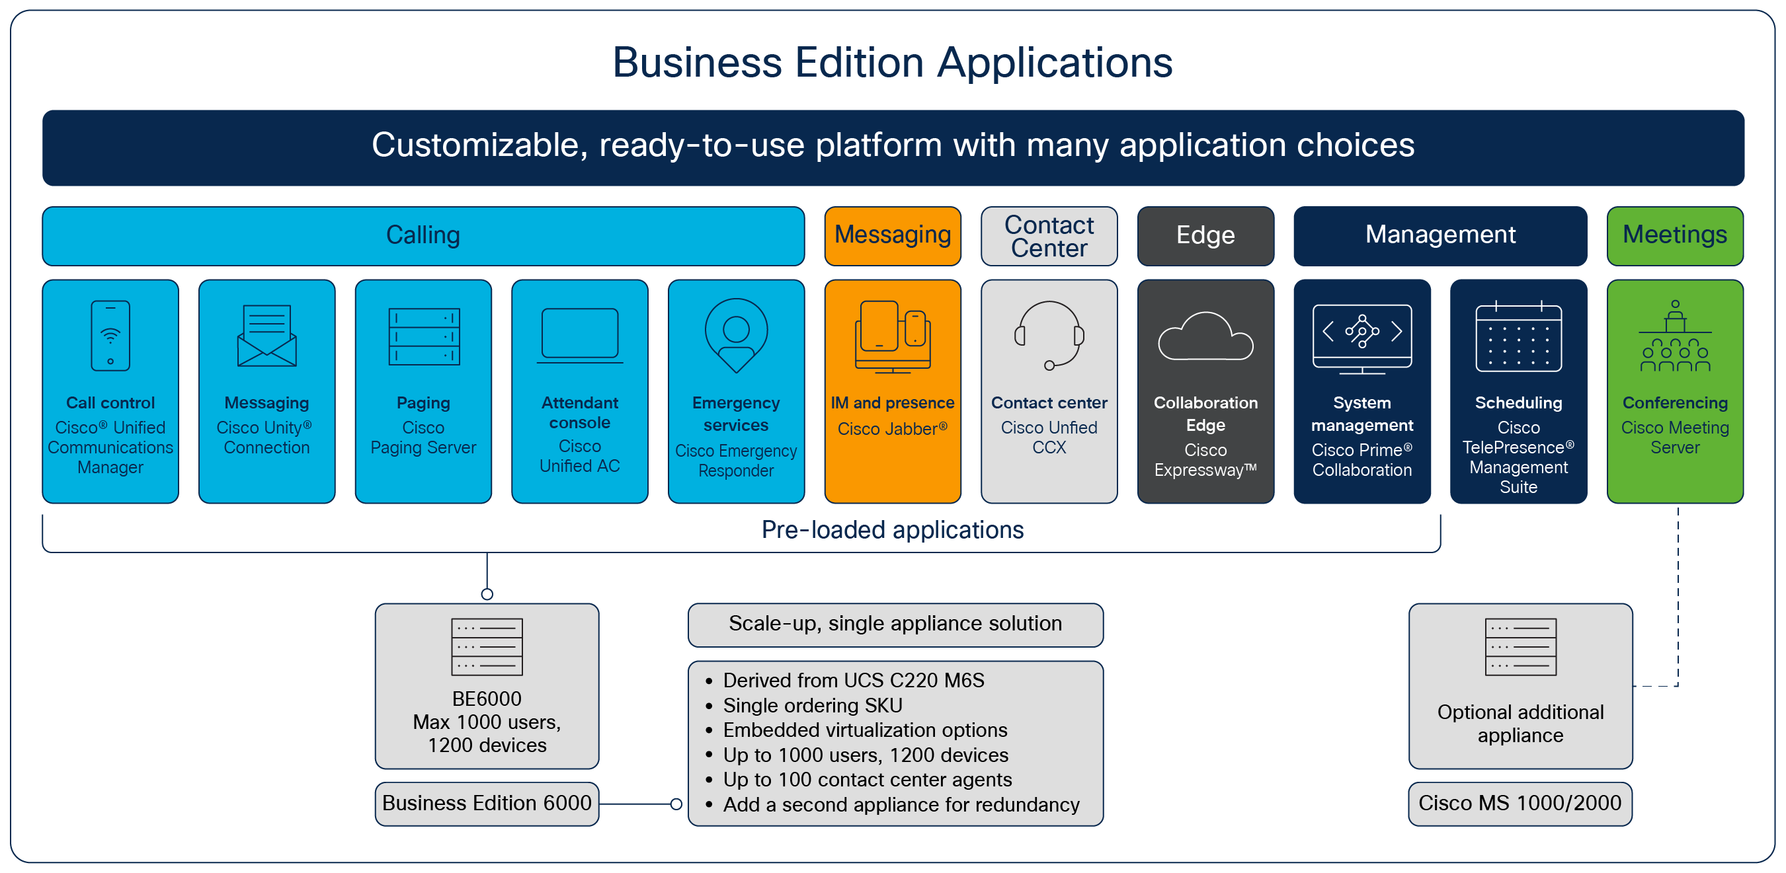

Cisco BE6000H/M: Built for Medium-Scale Collaboration Deployments
The Cisco BE6000 is a packaged solution that comes preloaded with virtualization and applications software. Simply turn on additional collaboration applications as your business needs grow.
Applications
The following applications are typically used together to deliver the core unified communications features of each BE6000 solution:
Calling
- Cisco Unified Communications Manager (Cisco Unified CM) is the call-processing engine of Cisco’s Collaboration Architecture. It extends voice and video features to network devices such as IP phones, telepresence endpoints, media-processing devices, gateways, and multimedia applications. Cisco Unified CM is equipped for use with the Instant Messaging (IM) and Presence Service. In addition, multimedia conferencing, collaborative contact centers, and interactive multimedia response systems are made possible through its open telephony APIs.
- Cisco Unified Attendant Consoles provide the human attendant console operator with the tools to quickly accept and effectively dispatch incoming calls to individuals across the organization.
- Cisco Emergency Responder helps assure that Cisco Unified Communications Manager sends emergency calls to the appropriate United States Public Safety Answering Point (PSAP) for the caller's location, and that the PSAP can identify the caller's location and return the call if necessary. The system automatically tracks and updates equipment moves and changes, helping ensure better compliance with legal or regulatory obligations and reducing the risk of liability related to emergency calls as a result.
- Cisco Paging Server provides paging capabilities for all users. It supports basic and advanced paging features. Basic paging features require no license and allow point-to-point or group audio paging between groups of up to 50 Cisco IP phones. An advanced paging license allows unlimited paging groups. It also makes possible other advanced functions, including paging to overhead analog and IP speakers, bell scheduling, prioritizing emergency notifications with the call-barge option, prerecorded and text-only pages, integration with social media sites for notification, email and Short Message Service (SMS) mass notification and all-number monitoring, Emergency Services alerting, and integration with Cisco Jabber clients.
Messaging
- Webex® App combines important team collaboration capabilities, such as calling, meeting, messaging, whiteboarding, and content sharing into one simple interface that integrates with additional cloud-based business applications, such as SharePoint, Box, and many others. Webex connects your teams with external teams, including customers and partners, to bring all collaboration activities together in one convenient space.
- Cisco Unified Communications Manager IM and Presence Service provides embedded standards-based enterprise instant messaging and network-based presence. The service is secure, scalable, easy to manage, and rich in features. It’s tightly integrated with Cisco Jabber® desktop and mobile instant messaging and presence clients and the Cisco Jabber Software Development Kit (SDK). Collaboration clients such as Cisco Jabber use products from the Cisco collaboration portfolio to perform many functions, such as instant messaging, presence, click-to-call, phone control, voice, video, visual voicemail, and web collaboration.
- Cisco Unity® Connection integrates voice-messaging and voice-recognition functions to provide continuous global access to calls and messages. Its advanced convergence-based communication services allow you to use natural-language voice commands to place calls or listen to messages in hands-free mode and to check voice messages from your desktop, either from your email inbox or in a web browser. It also provides robust auto-attendant functions, including intelligent routing for incoming calls and easily customizable call-screening and message-notification options.
Contact Center
- Cisco Unified Contact Center Express product line helps businesses and organizations deliver a connected digital experience, enabling you to provide contextual, continuous, and capability-rich journeys for your customers, across time and channels. This easy-to-deploy and easy-to-use solution is designed for midmarket companies or enterprise branch offices. Secure and highly available, it supports powerful agent-based services and fully integrated self-service applications, including Automatic Call Distributor (ACD), Interactive Voice Response (IVR), Computer Telephony Integration (CTI), and digital channels, including email and chat.
Edge
- Cisco Expressway™ is an advanced gateway that helps make collaboration as simple, secure, and effective outside the organization as it is inside. Expressway provides remote access to mobile users and teleworkers, without the need for a separate VPN client. It supports business-to-business and business-to-consumer collaboration, and video interoperability with third-party standards-based systems. Expressway also enables seamless hybrid collaboration experiences, connecting on-premises unified communications assets to Webex® cloud services.
Management
- Cisco Prime Collaboration Deployment is an application that is designed to assist in the management of unified communications applications. It allows you to perform tasks such as migration of older software versions to new virtual machines, fresh installs, and upgrades of existing applications.
- (Not preloaded) Cisco TelePresence® Management Suite offers flexible scheduling capabilities for video meetings, including the ability to integrate with Microsoft Exchange and Microsoft 365. At the core of the Cisco collaboration infrastructure portfolio, the suite facilitates on-premises video collaboration. It works with Cisco Meeting Server and Cisco TelePresence Server deployments.
Meetings
- (Not preloaded) Cisco Meeting Server brings premises-based video, audio, and web communication together to meet the collaboration needs of the modern workplace. It works with third-party devices and provides an enjoyable and intuitive user experience. It also scales easily and can be purchased using our all-in-one, user-based multiparty licensing offer.
In addition, Business Edition 6000 appliances support co-residency of approved third-party collaboration applications as described in the Co-Residency Policy.
Solution specifications: System capacity
Tables 1 and 2 list the system capacities supported by the BE6000 platform models. For solution design guidance and deployment models, please refer to the Preferred Architecture for Midmarket Collaboration and Cisco Validated Designs guides. The Cisco Solutions Reference Network Design (SRND) guides and the Cisco Collaboration Virtualization document are also available for more advanced implementations, as required.
- Cisco BE6000M and BE6000M Models System Capacity
Attribute | Capacity
Maximum number of users | 1000
Maximum number of mailboxes and voicemail ports | 1000 mailboxes and 24 voicemail ports
Number of contact center agents | 100
Number of presence users | 1000
Number of devices supported | 1200
Maximum number of co-resident applications | Varies by deployment; typically 5 to 7 per appliance
- Ordering Cisco Business Edition 6000 Platform Models
Part Number | Description
BE6K-M6-K9 | Cisco Business Edition 6000 Svr (M6), Export Restricted SW
BE6K-M6-XU | Cisco Business Edition 6000 Svr (M6), Export Unrestrict. SW
Licensing
Each BE6000 appliance requires a license for VMware vSphere ESXi, which may be purchased from Cisco or customer-provided. The collaboration applications in the BE6000 platform models are licensed on a per-user basis. Each BE6000 customer may purchase a Cisco Collaboration Flex Plan subscription at various feature levels for each of their users and common area devices. Cisco Collaboration Flex Plan provides simplified purchasing with flexible payment options, easily extensible functionality from calling and messaging to meetings and contact center, flexible migration to the cloud and enhanced visibility into collaboration usage. For more information, see https://www.cisco.com/c/en/us/products/unified-communications/collaboration-flex-plan/index.html.
Ordering information
To order any BE6000 platform model, simply purchase the required number of appliances (using the part number[s] in Table 2). Then purchase a virtualization software license from Cisco or choose to bring your own, and add application subscriptions to enable the required mix of features and number of users. Cisco channel partners and resellers can refer to the Cisco Business Edition 6000 Ordering Guide for further information.
To place an order, contact your local Cisco representative or visit Locate a Partner on cisco.com. Search on “Advanced Collaboration Architecture Specialization (ACAS),” or “Cisco Express Collaboration Specialization” to find a certified unified communications partner in your local area.
Cisco Services
Cisco Services help you accelerate cost savings and productivity gains associated with deploying Cisco Unified Communications in your network. Delivered by Cisco and our certified partners, our portfolio of deployment and technical support services is based on proven methodologies for unifying voice, video, data, and mobile applications on fixed and mobile networks.
Our unique lifecycle approach to these services can help you provide your users with powerful new ways to collaborate with co-workers, partners, and customers across any workspace to accelerate business advantage.

To learn more, please visit https://www.cisco.com/go/ucservices.
Cisco Capital
Flexible payment solutions to help you achieve your objectives
Cisco Capital makes it easier to get the right technology to achieve your objectives, enable business transformation and help you stay competitive. We can help you reduce the total cost of ownership, conserve capital, and accelerate growth. In more than 100 countries, our flexible payment solutions can help you acquire hardware, software, services and complementary third-party equipment in easy, predictable payments. Learn more.
For more information
To learn more about Cisco Business Edition 6000 solutions, visit: https://www.cisco.com/go/be6000.
To learn more about Cisco's complete portfolio offering for midmarket, visit: https://www.cisco.com/go/midmarket.
To learn more about resources for Cisco channel partners, visit: https://www.cisco.com/go/bepartner.
Document history
New or Revised Topic | Described In | Date

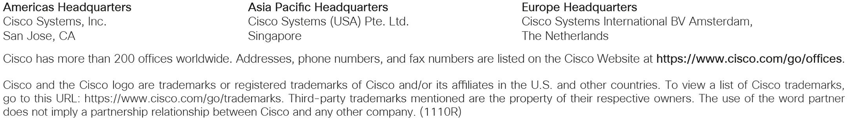
Printed in USA C78-717454-22 12/22

